**STŘEDOŠKOLSKÁ ODBORNÁ ČINNOST**

**Field No. 2: Physics**

**Sunspot classification using artificial intelligence**

**Eduard Plic**

**Pilsen Region Pilsen, 2024**

**STŘEDOŠKOLSKÁ ODBORNÁ ČINNOST**

**Field No. 2: Physics**

**Sunspot classification using artificial intelligence**

**Author:** Eduard Plic

**School:** Masaryk Gymnasium, Pilsen, Petákova 2, 301 00 Pilsen

**Region:** Pilsen Region

**Consultant:** Ing. Martin Bulín, M.Sc.

Pilsen, 2024

**Acknowledgments**

First of all, I would like to thank my supervisor and consultant, Ing. Martin Bulín, M.Sc. from the Faculty of Applied Sciences at the University of West Bohemia. His willingness to assist in the creation of this work, his expert opinions on topics related to machine learning, and his friendly approach in model development were indispensable.

I would also like to express my sincere gratitude to Martina Pavelková from the Astronomical Institute of the Czech Academy of Sciences. Her generous provision of all the necessary data and her warm welcome at the observatory in Ondřejov were crucial for the success of this work.

Last but not least, I would like to thank my physics teacher RNDr. Miroslav Randa, Ph.D. from Masaryk Grammar School, Pilsen. His friendly clarification of additional physics questions was very helpful to me.

I would also like to extend a big thank you to the astronomer Lumír Honzík, for leading the motivating astronomy club and for his dedicated proofreading of the text.

Another person deserving of thanks is Dr. Werner Pötzi from the Kanzelhöhe Observatory for the prompt provision of data from their research institute.

I also thank my family and friends for their support in writing this work.

**Annotation**

This work deals with the possibilities of using artificial intelligence for the classification of groups of sunspots. The main objective of the work is to create a convolutional neural network model capable of categorizing groups according to the McIntosh classification. The input data consists of modified sunspots drawings from the Astronomical Institute of the Czech Academy of Sciences, with training conducted using the Python programming language. By showcasing a model capable of classifying solar spot groups, the work proves that machine learning can be utilized for processing data of active regions on the Sun. The work also describes further possible steps that would lead to improved prediction accuracy.

Top of Form

**Keywords**

sunspots; artificial intelligence; convolutional neural networks; McIntosh classification; sunspot drawing

Content

1 Introduction 7

2 The Sun 8

2.1 Layers of the Sun 8

3 Sunspots 9

3.1 Schwabe cycle 9

3.2 Formation of Sunspots 10

3.3 Groups of Sunspots 11

3.3.1 Polarity of Groups 11

3.3.2 Wolf number 11

3.4 Classification of Active Regions 12

3.4.1 Zurich Classification 12

3.4.2 McIntosh Classification 13

3.4.3 Mount Wilson Classification 15

3.5 Sunspot Drawing 16

3.5.1 Drawing Procedure 17

3.5.2 Information in the Record 17

4 Machine Learning 19

4.1 Neural Networks 20

4.1.1 Convolutional Neural Networks 22

4.2 Machine Learning Tools 23

4.2.1 Python Programming Language 23

4.2.2 TensorFlow and Keras Libraries 23

4.2.3 Visual Studio Code Editor 24

4.2.4 Git and GitHub Systems 24

5 Sunspot classification using AI 25

5.1 Input data 25

5.1.1 Modification of the Input Drawing 26

5.1.2 Detection of Rectangles 26

5.1.3 Classification of data 27

5.1.4 Data Preparation for Training 28

5.2 Model Architecture 29

6 Results of the work 30

6.1 Classification into Two Classes 30

6.1.1 Model Axx-Dai 30

6.1.2 Model Axx-Bxo 31

6.2 Classification into Four Classes 32

6.2.1 Model Axx-Csi-Eac-Hsx 32

6.2.2 Model Axx-Bxi-Cai-Cso 33

6.3 Final Class Model 35

6.4 Classification by Letters 35

6.4.1 Model A-B-C-D-E-F-H 35

6.4.2 Model a-h-k-r-s-x 36

6.4.3 Model c-i-o-x 37

6.5 Final Letter Model 38

7 Discussion 40

7.1 Complications in Input Data Preparation 41

7.2 Extension of the Work 42

7.2.1 Creation of Additional Models 42

7.2.2 Implementation by Observatories 43

8 Conclusion 43

9 Použitá literatura 44

10 Seznam obrázků a tabulek 49

# Introduction

The main motivation of this work was to explore the potential use of artificial intelligence in solar astronomy, specifically in the classification of sunspots. The term "artificial intelligence" has become widely known, especially with the rise of chatbots and image-generating programs, and it is often misinterpreted and misused. At the same time, there is a trend to start utilizing these new tools in various fields, and this work aims to provide a proof of concept that machine learning can indeed be integrated into observatories.

The second goal was to demonstrate that it is possible to create a machine learning model capable of predicting the classification of an active region of the Sun with a certain degree of accuracy according to McIntosh's classification system. This model would be developed based on solar drawings that depict groups of sunspots. The model could then be used to verify observations made by humans. The work should provide a simple and concise guide on how to prepare input data suitable for training the model, how to correctly set the parameters of the neural network, and how to accurately assess the performance of these models.

Furthermore, the aim of this work was to provide a text that connects both thematic areas - solar astronomy and machine learning - clearly and from the ground up. The initial chapters provide information that a reader should know if they wish to create a classification model. These chapters summarize important and general facts about the Sun, address sunspots, their group classification, and the drawings themselves (for example, providing guidance on how to create a drawing). The work also familiarizes the reader with issues related to computer science, artificial intelligence, machine learning, and convolutional neural networks.

This work connects two fascinating areas of science while popularizing solar drawing. For over three centuries, systematic observations of the Sun through drawing have been conducted worldwide, yet only a few Czech observatories engage in this practice regularly. The Astronomical Institute is one such institution, offering many of its drawings for free download. In Ondřejov, home to one of the Institute's observatories, solar observation has a long tradition, with the first publicly available drawing dating back to 1944. The archive also includes data captured during World War II on photographic plates While some may argue that solar drawing is unnecessary in today's digital age, experts maintain its importance. This practice represents a continuous observational series since the 17th century, providing valuable insights when compared with satellite data from eras when such technologies did not exist.

As part of the work, a visit to the observatory of the Astronomical Institute in Ondřejov was made, where we had the opportunity to see the drawings firsthand. The friendly staff at the observatory demonstrated the drawing process and answered all our questions. We also learned about the current state of technology utilization and gained a better understanding of how the results of this work could be applied in practice.

The result of this work is a trained convolutional neural network model for predicting classifications, which is detailed in Chapter 6.5.

# The Sun

It is well known that the Sun is our closest star. The Sun is approximately one hundred fifty million kilometers[1] away from us, and its diameter is about 1.4 million kilometers[2]. By combining these two values, we can obtain the angular diameter of the solar disk, which is about 32 arc minutes, similar to the size of a quarter of an inch at arm's length. Due to this large angular diameter, even very small details can be studied very well using telescopes, satellites, and other instruments, allowing for a better and more detailed understanding of solar activity. One manifestation of solar activity is sunspots. Other manifestations include flares, prominences, filaments, granulation of the solar surface, and many others.

## Layers of the Sun

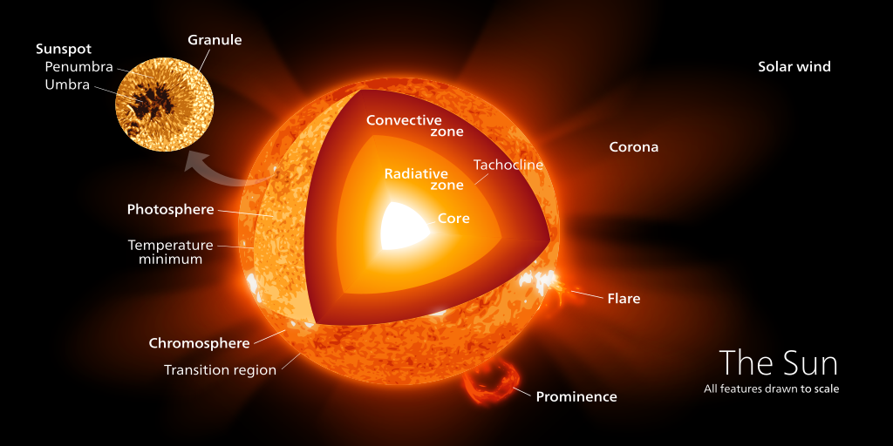Just as the Earth has various layers - core, mantle, crust, and atmosphere - the Sun can also be divided into similar layers, as shown in Figure 1.

At the center of the Sun is the core, where hydrogen is fused into helium, generating radiant energy. Next is the layer of radiative equilibrium, where energy from the core reaches the surface through gradual absorption and re-emission. [3] The following layer is called the convective zone. Here, energy is transported by the flow of plasma, rather than by absorption and emission. Between these two layers is a relatively newly discovered shell called the tachocline. Its thickness is about 0.04 times the radius of the Sun, and according to recent findings, the generation of the magnetic field occurs precisely here due to the differing rotation of the radiative equilibrium layer, which rotates more like a solid body, and the convective zone, whose rotation resembles that of a liquid.

Figure 1: Layers of the Sun [4]

The lowest layer of the Sun's atmosphere is the photosphere. In this layer, surface granulation, facular fields, pores, and sunspots can be observed [5]. The next layer is the chromosphere, where eruptions, prominences, and dark filaments, for example, occur. The upper layer of the solar atmosphere is called the corona. It extends millions of kilometers into space, has a silvery color, and its shape changes depending on solar activity. Various types of rays can be observed in it, and coronal holes and condensations form within it.

# Sunspots

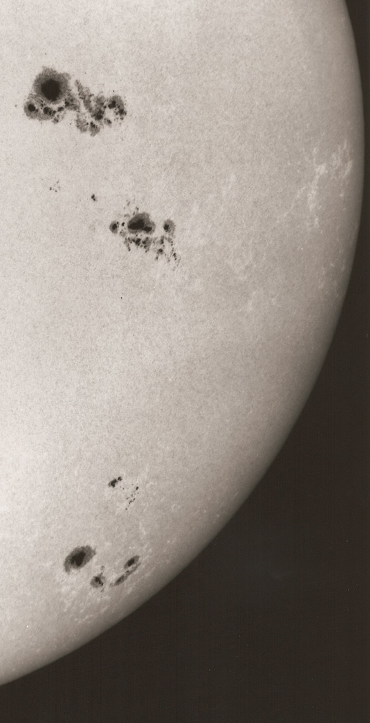Sunspots are dark formations often observable on the Sun. The first written record of their observation dates back to before our era and originates from Asia [6, 7]. Active observations of sunspots began with the invention of the telescope in the 17th century. Sunspots are locations in the lower layer of the solar atmosphere, in the photosphere, where magnetic induction lines rise to the surface. These spots are observable in the visible spectrum, as shown in Figure 2.

Sunspots can vary significantly in size, shape, and spatial distribution, making them suitable for thorough analysis. By observing sunspots, we can better understand the Sun and more accurately predict potential hazardous eruptions of solar material.

Figure 2: Sunspots on the Solar Disk [8]

Sunspots arise due to the Sun's magnetic field, which changes and twists due to differential rotation over the 11-year solar cycle. The positions of sunspots vary during this cycle. At the beginning of the cycle, during a solar minimum, sunspots appear in areas around +30° and -30° heliographic latitude, and as the cycle progresses, the sunspots move closer to the equator. The area of most probable sunspot occurrence is called the royal belt. The gradual shift of sunspot regions towards the equator throughout the cycle is represented in the so-called butterfly diagram, as shown in Figure 3. The graph also illustrates the distribution of individual cycles. Often, however, cycles overlap at their end and beginning, resulting in sunspots from two different cycles appearing on the disk simultaneously [9].

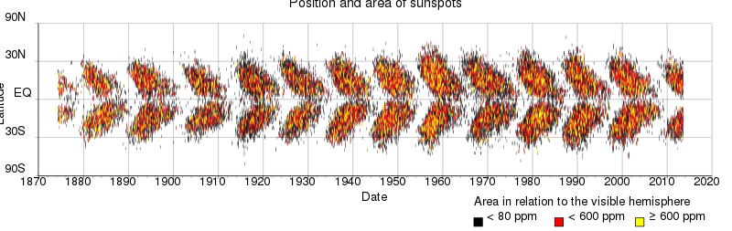Sunspots have been systematically observed for over four centuries. During this time, there have been significant changes in their observation. Although Johannes Fabricius first described sunspots in 1611 [11], attributing the discovery of sunspots to him, they were also observed with telescopes by Galileo Galilei and Thomas Harriot before him. Sunspots can also be observed with the naked eye. For sunspots to be visible, the Sun must be either obscured by a layer of translucent clouds or by a broader layer of the atmosphere. This occurs at sunrise or sunset, when the solar disk is near the horizon and light is weakened as it passes through the atmosphere. Sunspots were observed in this way thousands of years ago.

Figure 3: Butterfly Diagram [10]

## Schwabe cycle

The Sun has a certain periodicity in its activity. This period is approximately 11 years but can range between 7 and 15 years; it is known as Schwabe's solar cycle, Schwabe-Wolf cycle, sunspot cycle, or simply the solar cycle [12]. This cycle was discovered and described by the German pharmacist and amateur astronomer Heinrich Schwabe in 1843 based on observed data.

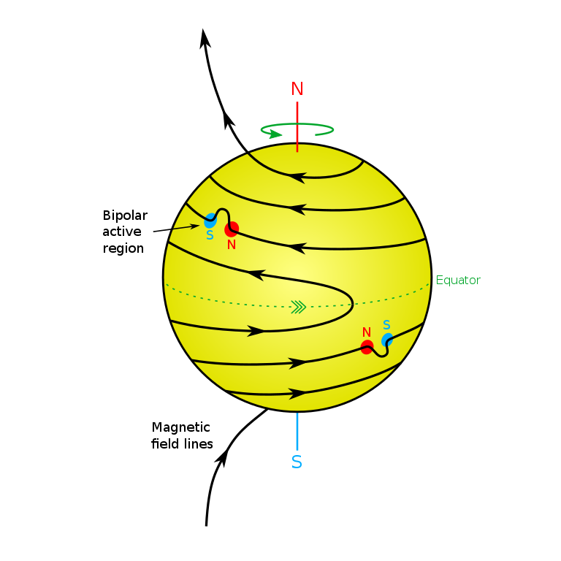The cycle is closely related to the Sun's magnetic field and, thus, to the formation and position of sunspots. Differential rotation plays a significant role in this cycle. It refers to the differing rotation rates at the solar equator compared to near the solar poles. While the solar equator rotates once every 25.4 days, it takes about 10.6 days longer for the area around the solar poles. Due to this rotation, magnetic induction lines become denser, leading to the formation of sunspots, as shown in Figures 3 and 4. At the beginning of its cycle, the Sun has its two magnetic poles at the northern and southern poles, where we would expect them, and the magnetic induction lines connect directly between both poles. Due to differential rotation, each magnetic induction line moves at different speeds at the equator and the poles, making the magnetic field more complex. The magnetic induction lines continue to condense in this manner. If the magnetic field becomes too complicated, reconnection occurs, leading to local magnetic poles forming at these points of reconnection. The entire cycle culminates in the magnetic reversal of the Sun, simplifying the system again, but this time with the opposite positions of the magnetic north and south poles. This process occurs approximately every 11 years. Globally, there is also reference to a 22-year cycle, which signifies the duration required for the magnetic poles to return to their original hemispheres..

Figure 4: Representation of Differential Rotation, Two Groups of Spots Visible on the Disk [13]

## Formation of Sunspots

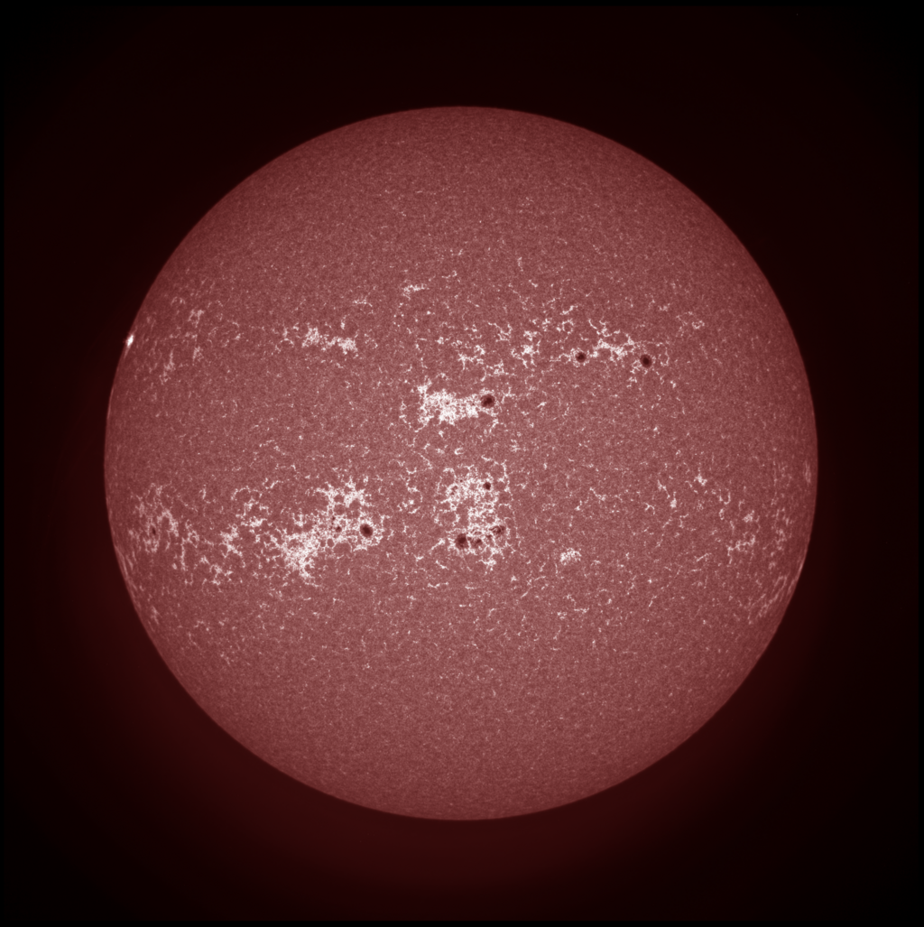A sunspot is a location where magnetic induction lines, which are normally beneath the surface, rise above the surface due to twisting and potential reconnection. These changes can then be observed in the photosphere and are referred to as sunspots or groups of sunspots. The area where the field lines emerge at the surface appears black, even though it has a temperature of around 4000 K. This area is called the umbra, or shadow. Surrounding the umbra, one can also observe the penumbra, or partial shadow, which serves as a transition between the typically granulated solar surface and the umbra, having a filamentary structure. The penumbra is lighter than the umbra because magnetic field lines here only partially prevent sufficient energy transfer from the convective layer.

Figure 5: Noticeable Bright Faculae and Dark Sunspots from August 2014 [14]

Before the formation of a sunspot, during its existence, and after its disappearance, facula fields typically appear in the same location, consisting of individual faculae, as shown in Figure 5. Faculae occur just like sunspots in the photosphere and are areas that are brighter than the solar disk because they have a temperature approximately 300 K higher than their surroundings. Facula fields, like sunspots, indicate a certain disruption in the magnetic field, but unlike sunspots, the magnetic field in facula fields remains below the surface of the Sun.

## Groups of Sunspots

Paradoxically, a group of sunspots can consist of just one spot, as the main characteristic of a sunspot is that it represents a closed system with poles. Therefore, we can have a very complex system of several dozen spots, which would still be considered one group of spots, just as a single spot can also be referred to as a group. Spots within a group can appear and disappear, but typically, two larger spots are evident, each having a specific name based on their position: the spot to the west is called the leading spot, while the one to the east is referred to as the trailing spot. [15] These spots usually last for the entire duration of the group’s existence. The size and arrangement of the group, the number of spots, and other parameters influence the group's longevity. Groups of sunspots most commonly last for several days, while smaller groups may only exist for a few hours, and larger groups can persist for weeks.

### Polarity of Groups

A group of sunspots is classified as either unipolar or bipolar. A bipolar group has more than two spots, with magnetic fields in at least one of them emerging and entering into other spots or the same spot back into the Sun. For these groups, the positive and negative poles can be determined using a magnetograph. The leading and trailing spots always have opposite polarities. In contrast, unipolar groups have magnetic induction lines that only emerge from the spot without entering into any specific pole. In reality, these lines connect uniformly to the entire solar disk. Unipolar groups typically contain only one spot, as having multiple spots would classify the system as bipolar.

### Wolf number

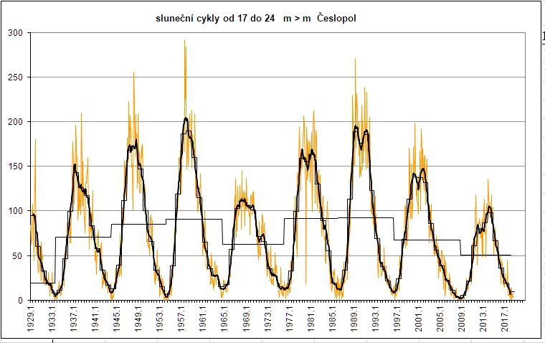The relative number is closely related to the size and number of spots within groups. This index is used to determine the overall solar activity and was introduced by astronomer Rudolf Wolf in the 19th century. [17] The calculation of this index is quite simple:

$R=10G+g$, (1)

where *R* is the relative number, *G* is the number of sunspot groups, and *g* is the number of individual spots. This index, sometimes referred to as Wolf's number, usually has a value between 0 and 300. [18] Because this index has been recorded for over two centuries, it is suitable for analyzing overall solar activity. However, it is not perfect, and other indices exist to describe solar activity. In practice, the resulting relative number is multiplied by an empirical coefficient that accounts for different observational instrument averages and the varying observational abilities of individual observers.

Figure 6: Graph of Relative Numbers from 1929 to 2017 Collected by the Česlopol Group [16]

## Classification of Active Regions

Sunspot groups, also known as active regions, can vary significantly from one another, necessitating the establishment of a systematic classification system. Currently, there are many such classifications that take into account factors such as the size of the group, its polarity, and its distribution. The primary motivation behind creating new classifications is to improve the prediction of eruption formation based on the structure of sunspots. At this time, there is no adequate method for accurately predicting the formation of eruptions, as this remains a very complex task.

### Zurich Classification

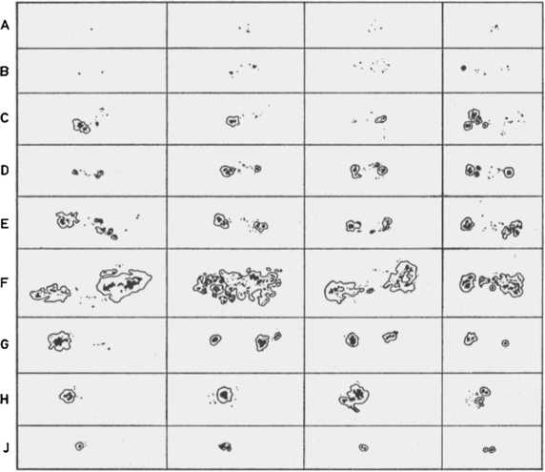One of the first and still-used classifications is the Zurich Classification, introduced in 1938 by M. Wiedermaier. The classification consists of a total of nine classes: A, B, C, D, E, F, G, H, J (see Figure 7), each with its own definition. [19].

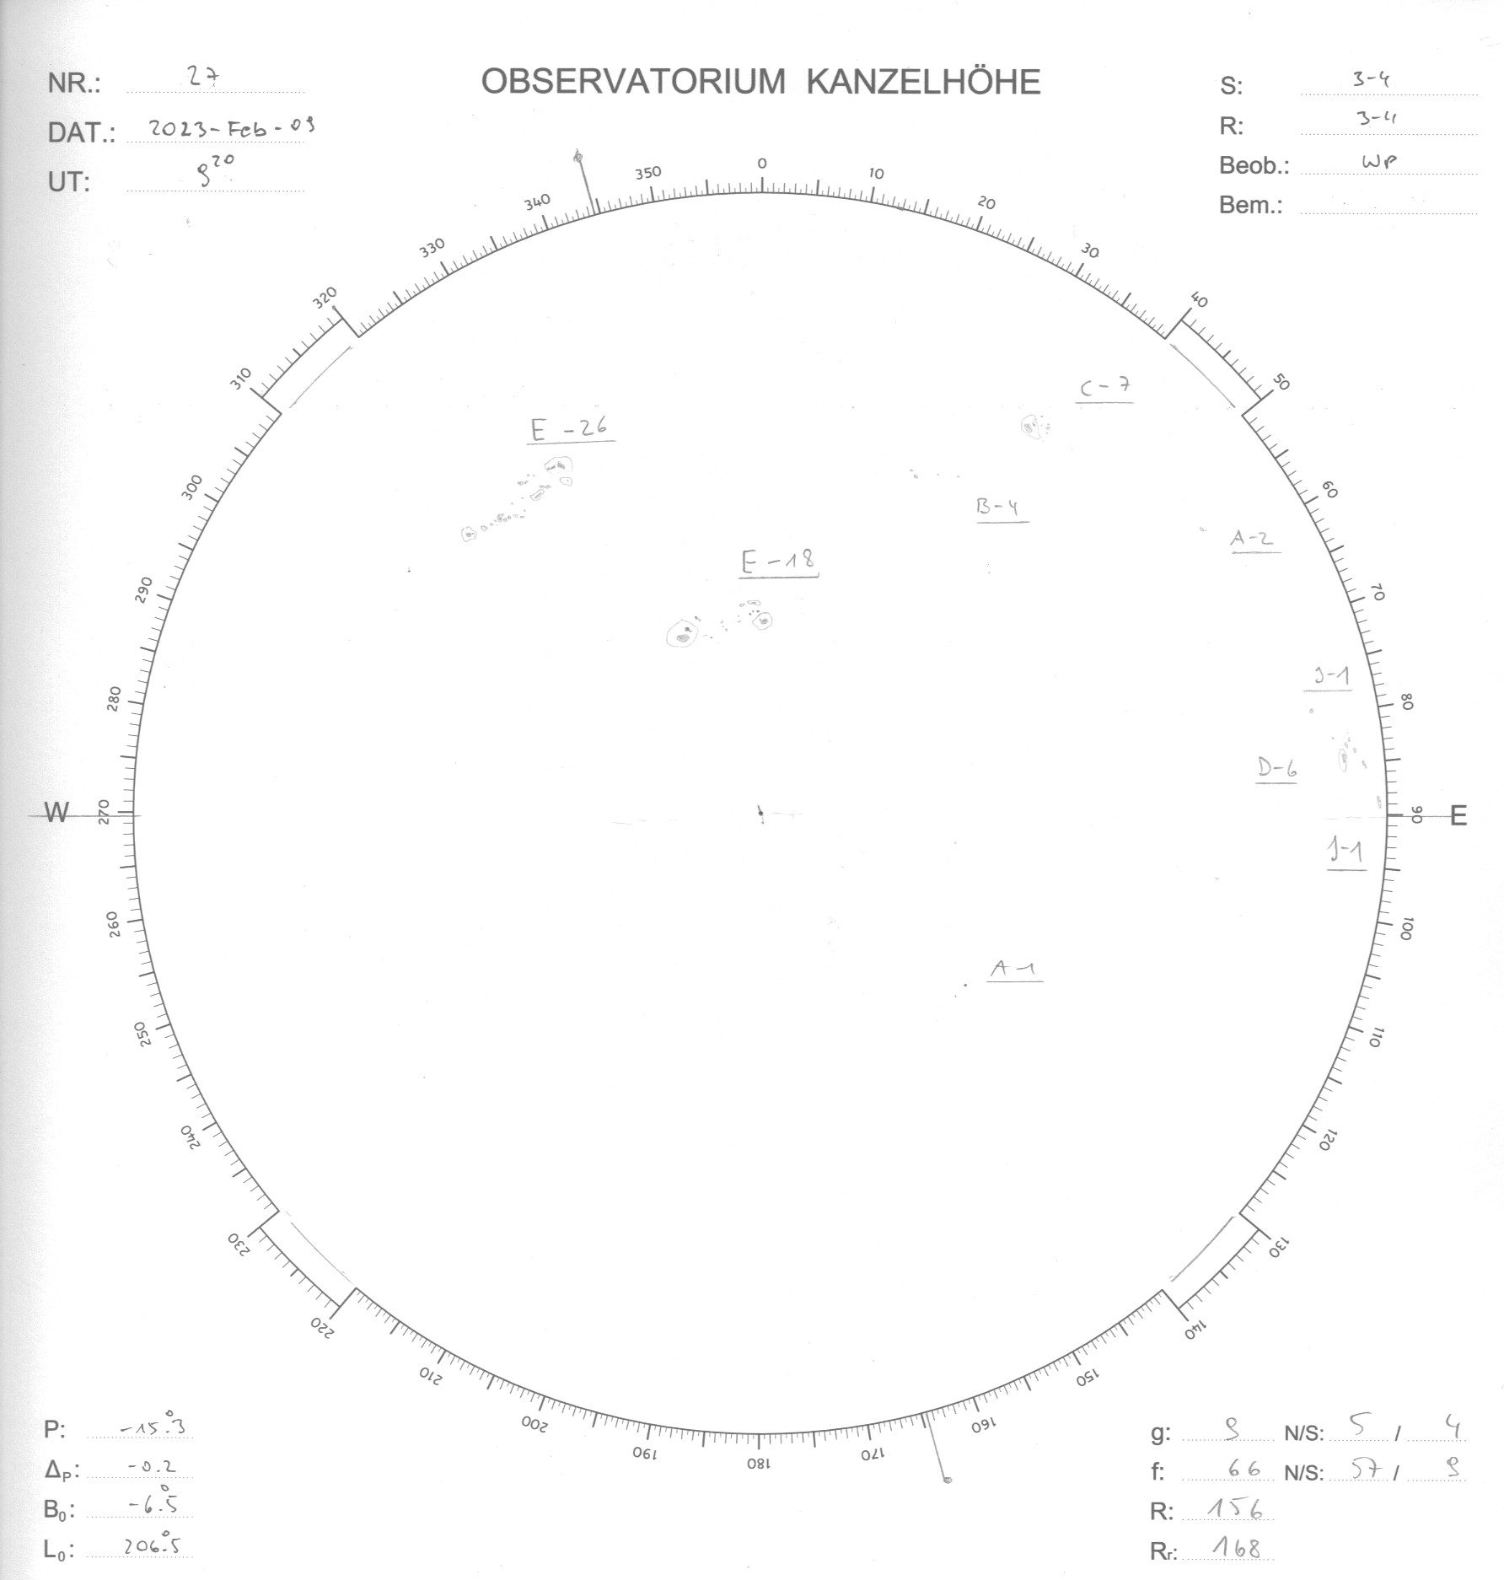A group classified as A consists of one or more spots without penumbra and without a bipolar configuration. Class B denotes a group without penumbra but with a bipolar configuration. Class C refers to a bipolar group of spots with one spot that has a penumbra. If the largest spot in both the leading and trailing parts of the group has a penumbra, and the entire group does not exceed a size of more than 10° (measured in heliographic coordinates on the surface of the Sun), the group is designated as D. If the spot is larger, specifically between 10° and 15°, it is classified as type E. An even larger group is labeled with the letter F. A bipolar group containing penumbra and no small spots between the main spots, with a length greater than 10°, is classified as class G. Classes H and J, which indicate the final stage, differ only in the size of the group: if it consists of one spot with a penumbra and a size greater than 2.5°, the group with only one spot is designated as H. If the spot is smaller than 2.5°, it is classified as type J. The arrangement of the classes reflects the development of the group, starting from class A and ending with class J; however, not all sunspot groups will pass through all classes.

Figure 8: Sunspotdrawing from Kanzelhöhe Observatory

Figure 7: Examples of Individual Classes of the Zurich Classification [20]

For better analytical examination, each category is assigned a weighting number, and by summing all these numbers for the individual spots, we obtain Beck's sunspot number. The weightings for each category are as follows: A = 4; B = 4; C = 8; D = 18; E = 25; F = 36; G = 50; H = 44; J = 37.

Beck's sunspot number is calculated using the following formula:

$R_{B}=\sum{w_{i}⋅f_{i}}$, (2)

where *wi* are the weighting numbers and *fi* is the number of spots in individual groups. [21] Unfortunately, the classification has not proven effective for predicting solar eruptions, necessitating its modification. This led to the development of the subsequent McIntosh classification. Nevertheless, this classification continues to be used, for example, at the Kanzelhöhe Observatory [22] in southern Austria (see Figure 8), mainly to maintain the historical record.

### McIntosh Classification

The McIntosh classification, developed in 1966, consists of three different, nearly independent classifications that together determine a three-letter designation for the group (see Figure 9). Spots can thus be designated, for example, as Axx, Dai, or Eso.

The first letters are A, B, C, D, E, F, H, and their definitions are very similar to those in the Zurich classification. Sometimes, this subclassification is referred to as the modified Zurich classification due to its continuity. Class A is a unipolar group without penumbra. Class B is a bipolar group without penumbra. Class C denotes a bipolar group that contains penumbra on one of its edges. If the group contains multiple penumbra, it will fall into one of three classes: D, E, or F. Here again, it depends on the size of the spot: if it is under 10°, it is classified as type D; between 10° and 15°, it falls into group E; and the largest spots are designated with the letter F. If it is a unipolar system with penumbra, it is designated with the letter H. [24]

Figure 9: Summary image for McIntosh classification [23]

The second letter of the classification characterizes the largest spot in the group. We have six classes to choose from, designated as x, r, s, a, h, k. Type x can only occur in combination with classes A or B, as this designation is used when the largest spot does not have a penumbra. Class r, from the English "rudimentary," denotes a situation where the penumbra is underdeveloped, incomplete, and irregular. Type s, from the English "symmetric," indicates a symmetrical penumbra smaller than 2.5°. Type a, from the English "asymmetric," is used when the penumbra does not exceed 2.5° and is not symmetrical; for example, in certain areas, it lacks clear boundaries. Type h is equivalent to type s, with the only difference being the size of the spot, which is greater than 2.5°. Type k is similarly equivalent to type a, meaning an asymmetrical penumbra exceeding 2.5°. [25]

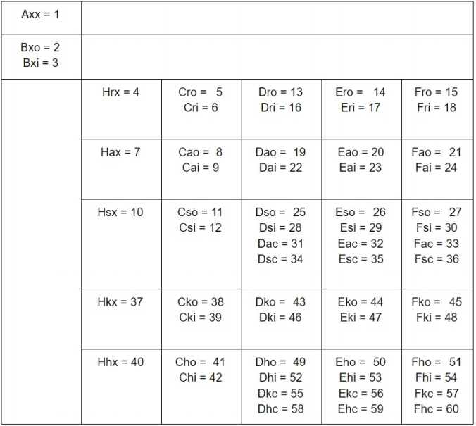The third symbol characterizes the distribution of spots in the group. The letters x, i, o, c are used to denote four classes. Type x indicates a unipolar group; thus, if we classify the group as A or H, it automatically receives the letter x. Class o, from the English "open," denotes a group where the spots are located at one or the other pole and not in between. Class i, from the English "intermediate," is reserved for configurations where spots lie between the poles of the group. However, if there is a spot with a penumbra between the leading and trailing spots, it would be classified as class c, from the English "compact."

Figure 10: Table with CV index values for all types of McIntosh classification [26]

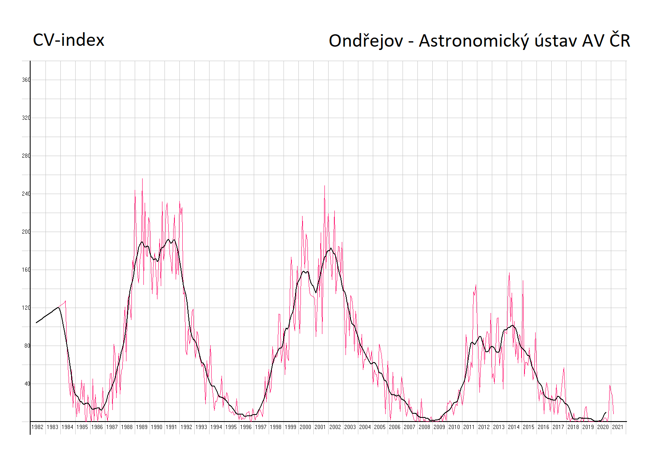As previously mentioned, not all letter combinations can be found, as some are tied to the presence of penumbra while others are associated with its absence. Therefore, only 60 classes can occur on the solar disk, and each of these classes has a value from 1 to 60, which is used to calculate the classification value, better known as the CV index or classification value. This is a modification of Beck's index from the Zurich classification. The CV index serves again to convert the classification into a number. Individual values, including all possible combinations of letters, are displayed in Figure 10. This value can also characterize solar activity (see Figure 11).

Figure 11: Collected CV index values by the Astronomical Institute of the Czech Academy of Sciences [27]

### Mount Wilson Classification

Another classification emerged based on observed data from magnetographs between 1959 and 1962 at the Mount Wilson Observatory. This classification has four main classes that can be combined in various ways. The classes are designated α, β, γ, δ, β-γ, β-δ, β-γ-δ, γ-δ. The letter α designates a unipolar group. Class β indicates a group of sunspots where spots with opposite polarities can be distinctly identified. Class γ designates a group that has a more complex polarity. The designation δ is very specific; it is used when both positive and negative polarities are present in the penumbra of one spot. The combination β-γ indicates a group that has distinct main spots of opposite polarity, but the boundary between the positive and negative poles of the group cannot be precisely determined. Class β-δ denotes a group with a magnetic field like class β but contains at least one δ spot (a spot with a penumbra of dual polarity). Class β-γ-δ has a distribution like class β-γ but again features one or more δ spots. The classification γ-δ represents a combination of class γ with at least one δ spot.

## Sunspot Drawing

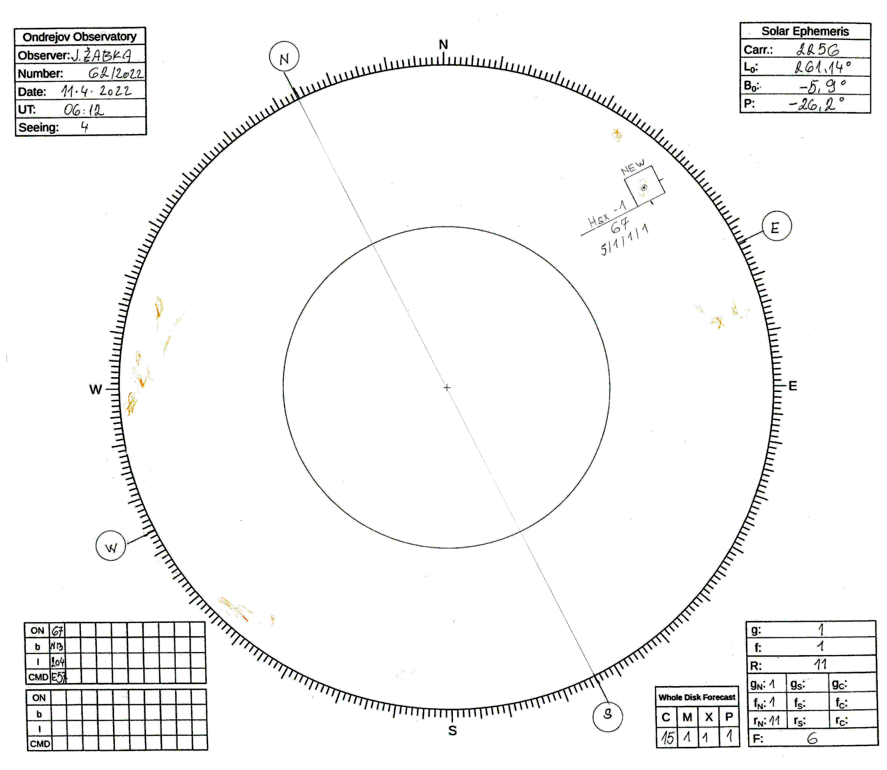Sunspot drawing is a method of capturing details on the Sun that was first used by Galileo Galilei. An example of a drawing is shown in Figure 12. In this method, a telescope is used as a projection device, projecting the Sun onto paper, where spots and other phenomena are then manually drawn. Despite modern technologies allowing for far higher quality information, this method remains the simplest (not only) for amateur astronomers. It is also the longest-used method for observing the Sun, and by combining new satellite data with new drawings, we can better refine what was happening at the time when the Sun was only being drawn. The Sun is typically drawn in records with a solar disk size of 25 cm; it should never be drawn on a disk smaller than 10 cm. Since the Sun is an angularly large object, a telescope with an objective diameter of 5 cm or larger and a focal length of 80 cm can be used for drawing. This telescope should have a polar mounting with a drive. Not only does this mount automatically track the Sun, but it also allows for easy orientation of the drawing by simulating daily movement, that is, movement in right ascension. [25]

Figure 12: Illustrative drawing from the observatory of the Astronomical Institute in Ondřejov [28]

### Drawing Procedure

Figure 13: Illustrative example of using a telescope to project the Sun onto a protocol [29]

The record, or drawn image of the Sun that is to be the output, has relatively many requirements that it must contain to be considered by the scientific community. Regular sunspot drawings are conducted by only a few observatories, scientific institutions, and amateurs in the Czech Republic. This is why a network of observers from the Czech Republic, Slovakia, and Poland called Česlopol was established, aiming not only to continue the observational series but also to digitize historical data. [30] This network, together with the Astronomical Institute of the Czech Academy of Sciences and the Solar Patrol based in Ondřejov, has compiled a manual on how to draw. The drawing procedure is as follows:

1. Aim the telescope at the Sun and place the form on the shade, as shown in Figure 13.
2. Turn off the clock drive, or simulate the daily movement of the Sun to orient the drawing.
3. Refine the orientation of the form by moving the spots along the line connecting east and west, and rotate the record so that the spot moves only along the line during movement in right ascension.
4. Turn the clock drive back on and place the Sun exactly on the form.
5. Draw the phenomena on the Sun. The umbra should be drawn fully black, the penumbra gray, and outlines and filaments in yellow or red crayon.
6. Check the accuracy of the drawing.
7. Fill in the information in the tables on the form.

### Information in the Record

The record must include various information: the date and time of the drawing, the observation location, and the observer's name, observing conditions (seeing) on a scale from 1 to 5 (where 5 is best), the drawing number, typically in the format drawing number in year/year. Furthermore, the record should also contain data about the solar disk: the heliographic latitude and longitude of the solar disk center, the angle by which the rotational axis of the Sun is tilted, and the Carrington rotation number, which indicates the order of the Sun's rotation around its axis since November 9, 1853. [31] The drawn groups of spots should be outlined in a rectangle and numbered, possibly also classified. The record should also include information about solar activity. This information includes the number of spots on the disk, the number of groups on the disk, and the Wolf number. Additionally, it is possible to distribute the groups of spots into three sectors: central, northern, and southern, and calculate these data only for the specific sector. Last but not least, the number of facula fields should also be indicated on the drawing. The record should also include information on the location of each group, namely the heliographic latitude and heliographic longitude of the center of the group, as well as their position relative to the center of the drawing. Heliographic coordinates of the group can be calculated using the following formulas: [26]

$ρ=\sin^{-1}{\frac{vz}{R}}$ (3)

$b=\sin^{-1}\left(\sin{B_{0}}\cos{ρ}+\cos{B_{0}}\sin{ρ\cos\left(P-Q\right)}\right)$ (4)

$l=\left(\sin^{-1}{\frac{\sin{ρ}\sin\left(P-Q\right)}{\cos{b}}}\right)+L_{0}$, (5)

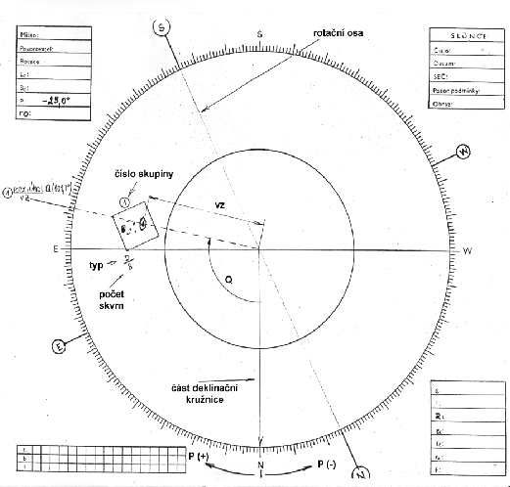where *vz* is the distance from the center of the spot to the center of the drawing, *R* is the size of the solar disk in the drawing, *B0* is the heliographic latitude of the center of the drawing, *L0* is the heliographic longitude of the center of the drawing, *P* is the positional angle of the Sun's rotational axis, and *Q* is the positional angle of the group measured on the drawing from north through east. The letters *b* and *l* are the sought heliographic coordinates, latitude and longitude, of the group. An illustration showing how to obtain the necessary data about the group is shown in Figure 14.

Figure 14: Occurrence of data in the drawing [32]

# Machine Learning

Machine learning can be understood as a collective term for methods and nonlinear algorithms aimed at accomplishing a specific task. This task can essentially be anything, from categorizing items, predicting numerical values based on past trends, finding similar data inputs, to generating content. Object categorization can be utilized in smart cars to map the surroundings using a camera, while a prediction model might try to estimate stock prices. Large language models that generate content are also gaining immense popularity, with examples like ChatGPT [33] and DALL-E [34] used for image generation.

Each task requires an individualized approach to development. [35] This can be divided into the following three categories:

1. Supervised learning
2. Unsupervised learning
   1. Semi-supervised learning
   2. Self-supervised learning
3. Reinforcement learning

The principle of supervised learning is straightforward: input data is paired with correct output data, and the program strives to generalize its behavior to utilize insights from training data on test data. For instance, it could involve images of a car and a dog, categorized based on what is depicted in the images. The model then accurately knows which inputs were labeled correctly and which were not, allowing it to improve based on this information.

In the case of unsupervised learning, the model is tasked with recognizing how input data belongs together on its own - by selecting suitable operations that cause similar data to cluster. An example could involve photographs of the night sky and flowers, where the program must independently divide the data into two groups based on the fact that some photos are dark and others are bright. This category can also include other methods characterized by the absence of input data with assigned correct outputs. One of these methods is semi-supervised learning, which is a combination of supervised and unsupervised learning. Additionally, it encompasses self-supervised learning, where algorithms do not require labeled output values for input data. This method leads to the development of large language models like Gemini [36], which typically can engage in dialogue with users. These models are trained on vast texts, where during learning, they randomly omit words from the input and then attempt to predict them. Since the model knows the word present in the input text and which word it would add, it has information regarding the accuracy of its completion and can use it for improvement.

Reinforcement learning learns based on positive or negative feedback for given actions or changes, but in a different form than supervised learning.

## undefined Neural Networks

A neural network is currently the dominant algorithm and method of machine learning, enabling the training of model behavior. The fundamental characteristic of neural networks is that they consist of neurons. The first artificial neuron was created in the mid-20th century. These artificial neurons are inspired by the neural cells in the brain. Neurons forming neural networks are interconnected (see Figure 15) and can be activated just like brain neurons. Neurons receive their activation level based on the values of previous neurons through simple mathematical operations.

Figure 15: Example of a feedforward neural network [37]

 The calculation of a neuron's value is very simple, allowing for the creation of extensive layers with many neurons and connections. Each neuron in a layer is connected to all neurons from the previous layer and has access to all previous neuron values. Therefore, there exists a connection between a neuron in a higher and lower layer, and this connection always has a certain weight. This weight can be understood as the importance of the connection, but primarily it is one of the trainable parameters of the neural network. The intermediate value of a neuron, denoted as *z*, is a linear combination of the input values. It is the sum of all the weighted values of previous neurons and a bias value (threshold), which is characteristic of each neuron and is not influenced by the input data:

Figure 16: The process of calculating the value of a neuron

$z=\sum_{i=1}^{n}{\left(x_{i}w_{i}\right)+b}$, (6)

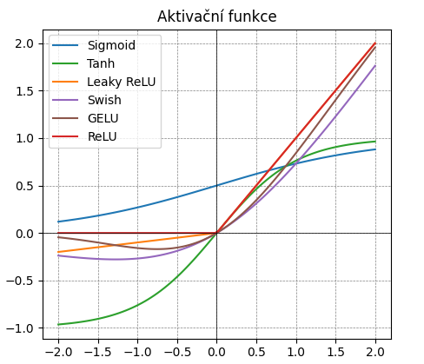where *xi* is the value of the previous neuron, *wi* is the weight of the connection between the two neurons, and *b* is the bias. The entire process is illustrated in Figure 16. In this figure, after the aforementioned summation, an activation function *f(z)* is applied. The purpose of using this function is to introduce nonlinearity into the entire process, significantly improving the training capabilities of models. This function is called an activation function [38], and an overview of the most basic ones is shown in Figure 17.

Figure 17: Example of some activation functions

The resulting value of the neuron *y* can then be formulated as:

$y=f\left(z\right)=f\left(\sum_{i=1}^{n}{\left(x_{i}w_{i}\right)+b}\right)$. (7)

As the previous text suggests, neurons in neural networks are arranged into layers. The first layer of neurons is called the input layer. This layer merely takes data from the input and possibly modifies it. This is followed by several hidden layers, each of which can have a different number of neurons. This number can either increase or decrease, depending on the specific task. Each of these layers is characterized by the connection of each neuron in the higher layer to all neurons from the previous layer. The last layer of the neural network is the output layer. In the case of classification tasks into various groups, it has exactly as many neurons as there are output classes. The values of these final neurons indicate the probabilities of the input being assigned to each class.

The passage of input data through the layers is referred to as forward propagation. The learning process occurs in the opposite direction and is known as backpropagation [39]. This process was described in 1970. To understand the concept of backpropagation, it is essential to mention the loss function [40], also known as the cost function. This function represents the overall success of the model. The lower its value, the better the model should be at distinguishing between classes. The goal of training is therefore to achieve the lowest possible value of the validation loss function, as this would correspond to the model being the most generalizable. The value of the loss function depends not only on the input data but also on all weights and biases of the model. Mathematical operations can determine how various parameters influence the shape of the resulting function, and based on this, these trainable parameters can be modified to enhance prediction accuracy. Usually, adjustments to parameters are not made in full scale; all changes are multiplied by a learning rate, which is typically less than one and results in slower parameter changes, leading to smoother training progress. After adjusting parameters, the model is provided with additional input data, and the entire process repeats. This approach can achieve generalization of the model for a wide range of input data.

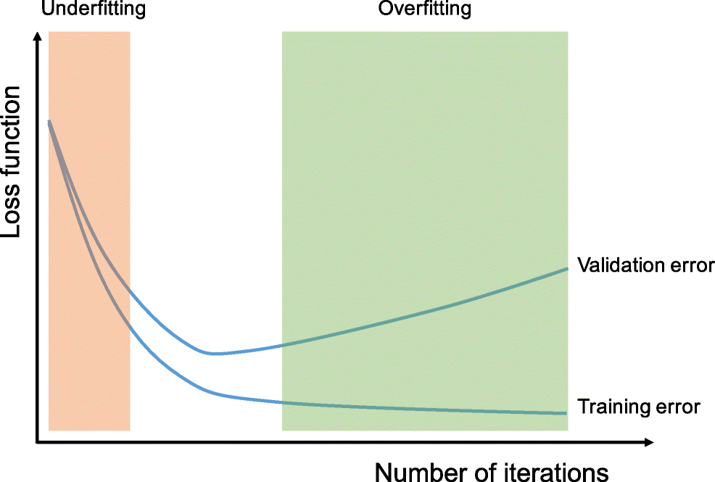In the training of large models, it is common for the backpropagation process to occur only after analyzing multiple input data samples, rather than a single one. The number of samples that the model classifies during a single step is referred to as batch size.

When continuously training the model on the same training data, overfitting may occur. The model may demonstrate higher accuracy on training data, but its accuracy on previously unseen test data will decrease. This happens because the model adjusts its trainable parameters to the previously seen images without generalizing. Although overfitting cannot be observed through the accuracy of the model during training, it can be detected from the value of the loss function on so-called validation data. Its value tends to increase again during overfitting, as illustrated in Figure 18.

Figure 18: Example of overfitting in the behavior of the loss function [41]

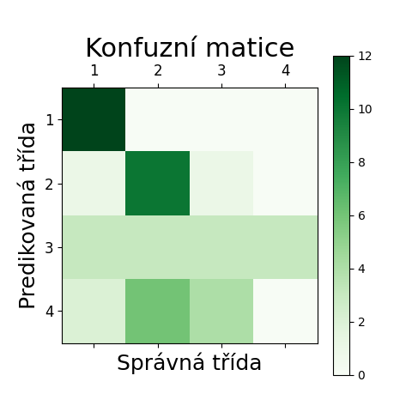Training occurs on input data, which is divided into three sets before beginning: training, validation, and testing [42]. This is also referred to as the training, validation, or test dataset. The model learns only from the training data, so this set should contain the most samples. After each epoch, the second set, validation, is examined as reference data, which allows the model to check its accuracy and overfitting. The test set then serves to evaluate the model's accuracy. This set should contain only data that the model was not exposed to during training; otherwise, the test results would not represent the model's behavior on random data. In the case of classification models, the results can also be interpreted using a confusion matrix. Its columns contain information about the correct assignment of output, while rows indicate the model's assignments. By looking at Figure 19, it can be seen that the model predicted classification into four classes; the first class was predicted perfectly, the second with minor errors, the samples of the third class were often misclassified as samples of all classes, and the fourth class was never correctly predicted, being most often confused with the second class.

Figure 19: Example of a confusion matrix

### Convolutional Neural Networks

 A Convolutional Neural Network (CNN) is a specific type of neural network that has proven effective in processing images. It was first described in 1998 in the paper "Gradient-Based Learning Applied to Document Recognition"[43]. Unlike the basic version of a feedforward neural network, CNNs have built-in information about the spatial layout of the input data, specifically the pixels in an image, allowing them to better understand the relationships between different elements within the input data. Additionally, some weights of the connections between neurons are shared, which significantly reduces the number of parameters, thus accelerating the network and allowing for the creation of more complex structures.

Figure 20: Calculation of neuron values in a convolutional network [44]

Convolutional neural networks can consist of various types of layers. Some are the same as those in classical neural networks, while others are characteristic of CNNs. The first such layer is the fully connected layer [45], which is a basic layer in classical neural networks, where neurons in this layer are connected to all neurons in the previous layer. CNNs are called convolutional due to their characteristic convolutional layers. These layers operate such that the value of a neuron in a higher layer is computed only from a specific region of the previous layer[3]. The weights of the connections are usually organized into matrices, most commonly sized 3×3, which are technically referred to as filters, or kernels in English. The computation of neuron values is illustrated in Figure 20.

Another set of specialized layers in CNNs are pooling layers, which reduce the dimensionality of the output from the previous layer. An example is the max-pooling layer, which takes only the highest value from a given region of neurons [46]. This results in a smaller layer, directly proportional to the area from which the highest value is selected, as shown in Figure 21. Another operation that can also be understood as a layer is flattening [48]. Flattening the data into a one-dimensional array does result in a loss of pixel position information but is necessary for the proper functioning of the final layers. More information about convolutional networks, their structures, methods, layers, and much more can be found online [49].

Figure 21: Example of a max pooling layer (2×2) [47]

## Machine Learning Tools

Although there are numerous ways to train a functional model, it is generally a straightforward and accessible process. However, it is essential to clearly define one’s objectives, choose the appropriate type of learning, adequately prepare the input data, and lastly, select the programming environment and language.

### Python Programming Language

Python is a programming language developed in the USA in 1991. It is an open-source project, meaning it is free to use and compatible with many operating systems, making it one of the most widely used programming languages. Python also allows the importation of libraries, which contain pre-written code that can easily be referenced in one’s own code [50].

### TensorFlow and Keras Libraries

TensorFlow is an open-source software library primarily designed for working with neural networks. The library was developed and released by Google in 2015. TensorFlow facilitates easier training, creation, improvement, and control of artificial intelligence model development [51].

Keras is also an open-source library that allows for easier communication and work with TensorFlow. It was first released in 2015 and enables the straightforward creation of layers, use of activation functions, acquisition of data about network structure, and evaluation of model performance during training [52].

### Visual Studio Code Editor

Visual Studio Code (VS Code) is an editor that allows for coding in various languages, enhances code organization and clarity, and provides tools for searching and fixing errors in source code. It can be used as a standalone application that can be integrated with GitHub [53].

### Git and GitHub Systems

GitHub can be understood as a web service that provides online storage, programming environments, web hosting, and much more. GitHub is widely used for storing and sharing code among selected collaborators through repositories, which are essentially shared storage spaces. A significant advantage of GitHub is that it employs the Git version control system [54], which tracks and stores data on changes made to files, most commonly source codes, allowing for easy retrieval of previously deleted content or viewing of file changes over time [55].

# Sunspot classification using AI

The aim of the work was to create a convolutional model that can successfully predict the classification of sunspot groups according to the McIntosh system based on the data collected so far. We chose the McIntosh classification for several reasons. First, the Observatory of the Astronomical Institute in Ondřejov [56] has been using this system since 1992 and has reclassified all its previous drawings from the Zurich to the McIntosh system. This allowed us to utilize 7,170 drawings from the period between 1971 and October 6, 2023. The observatory also provided us with electronic data containing the locations and classifications of 56,375 spots from March 25, 1944, to October 19, 2023. Another reason for selecting this classification is that it has three nearly independent subclasses, allowing us to examine the success rate for each subclass separately. Last but not least, it can be stated that this system is currently the most accurate, considering its global use. Unlike the Mount Wilson classification, it relies on visual data collected and processed over a long period rather than data from more sophisticated and recently employed magnetometers.

After adequately preparing the input drawings, we were able to use them to train the model. We divided the data into three sets: 80% for training, 10% for validation, and 10% for testing the model's accuracy. During the development of the convolutional networks, we created several datasets and tested various combinations of the neural network's adjustable parameters. The entire process, including the modification of the drawings, was programmed in Python with the help of libraries such as TensorFlow and Keras. We wrote the source code using Visual Studio Code, connected to a GitHub repository [57] to continuously save our work to cloud storage. We chose GitHub not only for its user-friendly interface but also for its ability to display the history of individual files.

## Input data

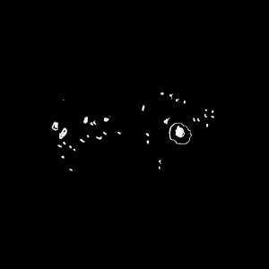To train the model, we required annotated groups of sunspots as input data. Specifically, we used 14,768 groups of spots extracted from 7,292 drawings in .jpg format provided by the Astronomical Institute. We then organized these groups into folders according to their classifications based on the digitized drawing data. To obtain the input data, as shown in Figure 22, we performed the steps described below.

Figure 22: Input data on which we trained the model; this is group Fsi.

### Modification of the Input Drawing

The first modification we made to the input drawing was to change its width to 2000 px while maintaining the same aspect ratio for the height. We deliberately chose this width because approximately 99.4% of the drawings are 2000 px wide, allowing us to avoid any modifications that could affect quality. The remaining drawings were mostly wider. Changing the dimensions of all images to nearly the same values is important because, during model training, we want it to have a correct understanding of the relative size of the groups on the disk. We then placed the image with the modified dimensions on a blank canvas of size 2000×1800 px. This ensured that the image could be moved freely in the next step without losing any significant parts.

In the next step, we machine-detected both auxiliary circles, as shown in Figure 23, found their exact center (the cross on the drawing), and centered the drawing based on its current position. This ensured sufficient normalization of the input drawings.

The last step before machine searching for groups was applying a mask that covered the tables in the corners of the protocol, as the program would detect these rectangular tables as well. We created the mask in a freely available image editor to cover the tables as much as possible while minimally affecting the actual capture of the Sun.

Figure 23: Example of machine detection of the large and small auxiliary circles; on the left, detection of the large circle with marked centers of detected circles, in the middle the same detection for the small circle, on the right, the machine-estimated position of the large circle with its center.

### Detection of Rectangles

In the next step, we created a copy of the processed drawing, where we made changes to better find the rectangles. Due to the varying quality of the scan and different pressure applied by the pencil during the drawing process, the program sometimes detected only part of the bounding rectangle. To improve the detection process, we replaced each pixel lighter than (220, 220, 220) with pure white and replaced any darker pixel with pure black. We then applied a blur to the copy and again replaced pixels lighter than (200, 200, 200) with white and vice versa. This step ensured that if a line was interrupted or weakened at any point, it would be connected. The process can be seen in Figure 24.

Next, various shapes were machine-found on the modified copy of the drawing. If these shapes had four corners, their width and height ranged from 10 to 1,000 px, all adjacent sides were perpendicular to each other, and the distance between all points was greater than 28 px, we considered the area to be correctly detected as a group. The correctly detected shapes are marked in green in Figure 25. We extracted an area of 300×300 px around the center of the detected shape only for such detected groups and saved it, as shown in Figure 26. We also stored the coordinates of the rectangle corners in a CSV table for further use.

Figure 24: The process of modifying a copy of the drawing to improve detection quality; in the upper left, the drawing with removed tables, in the upper right, the drawing after the first pixel replacement, in the lower left, the drawing after blurring, in the lower right, the drawing after the second pixel replacement.

### Classification of data

We calculated the heliographic latitude, the lengths of the sunspot disk center, and the angle at which the Sun's rotational axis is tilted for each drawing based on the time data. These values are also listed in the drawing protocol, but it is easier to compute them than to read them directly from the protocol using Optical Character Recognition (OCR) [58]. The program also determines the positional angle of each group and its distance from the center. From this data, we can calculate the heliographic latitude and height of the sunspot group, using the equations (3, 4, 5) provided in Chapter 3.5.2. Subsequently, we identified the sunspot record in the table provided by the Astronomical Institute and found its classification according to the McIntosh system. In this way, we were able to assign the McIntosh classification to 15,494 sunspot groups. We then created the necessary folder structure containing the annotated input data. The main folder contained directories named after the individual classes, and these folders contained images of the groups with that classification. From this structure, we could then select only the groups of interest and use them to train the supervised model, as described in Chapter 4.

Figure 25: Example of group detection; green detected groups of spots, brown detected other shapes.

### Data Preparation for Training

N First of all, the program removed duplicate images of groups because, especially with historical data, the program detected both the outer rectangle and the inner rectangle surrounding the group, resulting in the spot being saved twice. To simplify the functioning of the model, we decided to work with black-and-white images. The orange-yellow parts of the image (faculae) were then programmatically removed, and the image was converted to black-and-white. After a manual check, a white mask was applied to the group, covering the surrounding area and leaving only the interior of the rectangle with the spot. We then inverted the image, as the model worked better with a black background. Figure 26 provides a view of the modification of the group.

Figure 26: Adjustment of individual groups of spots to final form; on the far left, the extracted part of the drawing 300×300 px around the detected group, in the middle left, the group after removing penumbra areas, in the middle right, the surrounding area of the group covered, on the far right, the final form of the group.

We then divided the data necessary for creating the current model into training, validation, and testing directories. The folder with the fewest data was split into training (80%), validation (10%), and testing (10%) datasets. From the other folders, we took the same number of testing samples as we had from the smallest folder. The remaining images were split in an 8:1 ratio into training and validation folders. We chose this uneven distribution of datasets due to the significant variability in the number of samples for individual groups. Thus, each class had a different number of input data in the training and validation folders. However, to ensure the model's accuracy was not biased, the testing folder always contained the same number of groups from each class. Ultimately, we did not use class weighting, as models with weighting achieved very similar results to those without it.

## Model Architecture

Once we had prepared the desired structure for creating the convolutional neural network, we could begin training the individual models. In training all the models, we suitably chose the following parameters:

1. Batch size: The number of input data for one backpropagation process.
2. Steps per epoch: The number of learning steps within one epoch.
3. Validation steps: The number of validation steps for ongoing evaluation at the end of each epoch.
4. Number and structure of layers: The number and type of layers, the number of neurons in them, and the activation functions.

During training, the model was saved, and we considered the best model to be the one with the lowest loss function value on the validation data. We trained the model for a maximum of 300 epochs. The results were evaluated on the test data, which the model had not accessed during training and validation.

# Results of the work

## Classification into Two Classes

In general, these models should be highly accurate, as they involve a choice between one class or another. Additionally, it is possible to select classes for which we have sufficient data and that exhibit noticeable differences. Another significant advantage is that training fewer classes does not require powerful computing resources, allowing these models to be easily retrained with various parameters in a short time frame.

### Model Axx-Dai

This model is expected to be very accurate in distinguishing between groups Axx and Dai, as the difference between these two groups is pronounced. The Axx group consists of a solitary small spot, whereas the Dai group includes penumbrae, is noticeably larger, and, unlike the Axx group, the spots are more distributed towards the poles of the group rather than in its center. Both groups are shown in Figure 27. Additionally, we had hundreds of images of both groups, providing the model with more input data, which also contributes to accuracy.

Figure 27: Classes of the model Axx-Dai.

Parametry konvoluční sítě jsme zvolili následovně:

Tabulka 1: Vstupní data a parametry CNN modelu Axx-Dai

|  |  |  |  |  |  |  |
| --- | --- | --- | --- | --- | --- | --- |
| Počet tříd | Celkem vzorků | Počet vzorků v třídách Axx, Dai | Batch size | Steps per epoch | Validation steps | Počet vrstev včetně výstupní |
| 2 | 2499 | 1668, 831 | 32 | 24 | 38 | 7 |

Detailní struktura modelu pak vypadala takto:

Tabulka 2: Struktura CNN modelu Axx-Dai

|  |  |  |  |  |
| --- | --- | --- | --- | --- |
| Vrstva | Typ vrstvy | Počet neuronů | Velikost matice | Aktivační funkce |
| 1 | Konvoluční | 32 | 3×3 | ReLU |
| 2 | Maxpooling |  | 2×2 |  |
| 3 | Konvoluční | 16 | 3×3 | ReLU |
| 4 | Maxpooling |  | 2×2 |  |
| 5 | Flatten |  |  |  |
| 6 | Plně propojená | 24 |  | ReLU |
| 7 | Plně propojená | 2 |  | Softmax |

With this combination of parameters, we obtained the following results:

* Overall accuracy on test data: 98.21%
* Epoch with the lowest loss function value: 26
* Loss function value on validation data: 0.030498

The model learned to differentiate between the classes with nearly 100% accuracy in a relatively short time. This result was expected, as ideal conditions were established: noticeable diversity between classes, a large number of input data, and a simple structure.

### Model Axx-Bxo

In comparison to the previous model Axx-Dai, the Axx-Bxo model is expected to be less accurate because the Axx and Bxo groups differ significantly less from one another. The main distinction between these groups is that Axx represents a single spot, whereas Bxo consists of multiple spots. The appearances of both classes are illustrated in Figure 28. This fact should allow the convolutional neural network to learn to differentiate between them relatively well. Furthermore, we have a substantial amount of data available from both classes, which should also enhance accuracy.

Figure 28: Classes of the model Axx-Bxo.

Parametry konvoluční sítě jsme zvolili následovně:

Tabulka 3: Vstupní data a parametry CNN modelu Axx-Bxo

|  |  |  |  |  |  |  |
| --- | --- | --- | --- | --- | --- | --- |
| Počet tříd | Celkem vzorků | Počet vzorků v třídách Axx, Bxo | Batch size | Steps per epoch | Validation steps | Počet vrstev včetně výstupní |
| 2 | 3429 | 1668, 1761 | 32 | 20 | 60 | 5 |

Detailní struktura modelu pak vypadala takto:

Tabulka 4: Struktura CNN modelu Axx-Bxo

|  |  |  |  |  |
| --- | --- | --- | --- | --- |
| Vrstva | Typ vrstvy | Počet neuronů | Velikost matice | Aktivační funkce |
| 1 | Konvoluční | 16 | 3×3 | ReLU |
| 2 | Maxpooling |  | 2×2 |  |
| 3 | Flatten |  |  |  |
| 4 | Plně propojená | 16 |  | ReLU |
| 5 | Plně propojená | 2 |  | Softmax |

With this combination of parameters, we obtained the following results:

* Overall accuracy on test data: 89.52%
* Epoch with the lowest loss function value: 53
* Loss function value on validation data: 0.300535

It is evident that the model learned to recognize both categories quite well. The accuracy could potentially be increased by adding more layers. Another option to improve model performance would be to crop the input images to a smaller size, as both groups, Axx and Bxo, are relatively small.

## Classification into Four Classes

Models should still classify groups into the correct categories with high accuracy; however, they are generally not expected to be more accurate than the two-class models, as accuracy tends to decrease with an increasing number of classes.

### Model Axx-Csi-Eac-Hsx

 In creating the dataset, we intentionally selected four distinct groups, so the neural network should be able to detect these significant differences. The Axx group is simply a unipolar spot. The Csi group contains only one spot with a penumbra, while the other groups do not. The Eac group is the most complex of these data, containing both spots with and without penumbra, and the distribution of spots is compact. The Hsx group is also a unipolar spot like Axx, but in contrast, it features a penumbra. All class representations are shown in Figure 29. Thus, it is likely that the model will make errors primarily between the Csi and Eac groups or between Axx and Hsx, rather than between other combinations, as these pairs are the least distinct yet still markedly different.

Figure 29: Classes of the model Axx-Csi-Eac-Hsx.

Parametry konvoluční sítě jsme zvolili následovně:

Tabulka 5: Vstupní data a parametry CNN modelu Axx-Csi-Eac-Hsx

|  |  |  |  |  |  |  |
| --- | --- | --- | --- | --- | --- | --- |
| Počet tříd | Celkem vzorků | Počet vzorků v třídách Axx, Csi, Eac, Hsx | Batch size | Steps per epoch | Validation steps | Počet vrstev včetně výstupní |
| 4 | 3991 | 1668, 572, 206, 1545 | 20 | 96 | 128 | 7 |

Detailní struktura modelu pak vypadala takto:

Tabulka 6: Struktura CNN modelu Axx-Csi-Eac-Hsx

|  |  |  |  |  |
| --- | --- | --- | --- | --- |
| Vrstva | Typ vrstvy | Počet neuronů | Velikost matice | Aktivační funkce |
| 1 | Konvoluční | 32 | 4×4 | ReLU |
| 2 | Maxpooling |  | 3×3 |  |
| 3 | Konvoluční | 16 | 3×3 | ReLU |
| 4 | Maxpooling |  | 2×2 |  |
| 5 | Flatten |  |  |  |
| 6 | Plně propojená | 32 |  | ReLU |
| 7 | Plně propojená | 4 |  | Softmax |

With this combination of parameters, we obtained the following results:

* Overall accuracy on test data: 92.86%
* Epoch with the lowest loss function value: 46
* Loss function value on validation data: 0.219321

The convolutional neural network achieved a very accurate prediction of individual classes, with an accuracy close to 92%. Confusion Matrix 1 can be viewed in Figure 31. Additionally, we can clearly observe the correlation between the number of classes and overall accuracy, as the Axx-Dai model achieved an accuracy of 98.21%. For both of these models, we intentionally selected very different input data. When developing the next model, it would be prudent to consider the number of steps per epoch or the batch size value, as the model began to show signs of overfitting around the 75th epoch, where the validation function reached values around 0.24.

### Model Axx-Bxi-Cai-Cso

The model attempting to classify groups of sunspots into classes Axx, Bxi, Cai, and Cso has a relatively complex task. Unlike the classes of the previous model, these classes do not differ significantly from one another. The groups beginning with the letter C feature spots with a penumbra, which the model should ideally learn to recognize. The distinction between the Cso and Cai groups lies, in addition to the shape of the penumbra, in the arrangement of spots within the group; one group has an open distribution of spots, while the other has a transitional arrangement, meaning spots also appear in the center of the group. The Bxi group contains only umbral spots distributed throughout its area. The Axx group consists of a single unipolar spot. All groups are shown in Figure 30.Parametry konvoluční sítě jsme zvolili následovně:

Figure 30: Classes of the model Axx-Bxi-Cai-Cso.

Tabulka 7: Vstupní data a parametry CNN modelu Axx-Bxi-Cai-Cso

|  |  |  |  |  |  |  |
| --- | --- | --- | --- | --- | --- | --- |
| Počet tříd | Celkem vzorků | Počet vzorků v třídách Axx, Bxi, Cai, Cso | Batch size | Steps per epoch | Validation steps | Počet vrstev včetně výstupní |
| 4 | 4233 | 1668, 1134, 662, 769 | 32 | 14 | 36 | 7 |

Detailní struktura modelu pak vypadala takto:

Tabulka 8: Struktura CNN modelu Axx-Bxi-Cai-Cso

|  |  |  |  |  |
| --- | --- | --- | --- | --- |
| Vrstva | Typ vrstvy | Počet neuronů | Velikost matice | Aktivační funkce |
| 1 | Konvoluční | 16 | 4×4 | ReLU |
| 2 | Maxpooling |  | 3×3 |  |
| 3 | Konvoluční | 8 | 3×3 | ReLU |
| 4 | Maxpooling |  | 2×2 |  |
| 5 | Flatten |  |  |  |
| 6 | Plně propojená | 32 |  | ReLU |
| 7 | Plně propojená | 4 |  | Softmax |

With this combination of parameters, we obtained the following results:

* Overall accuracy on test data: 66.05%
* Epoch with the lowest loss function value: 297
* Loss function value on validation data: 0.569998

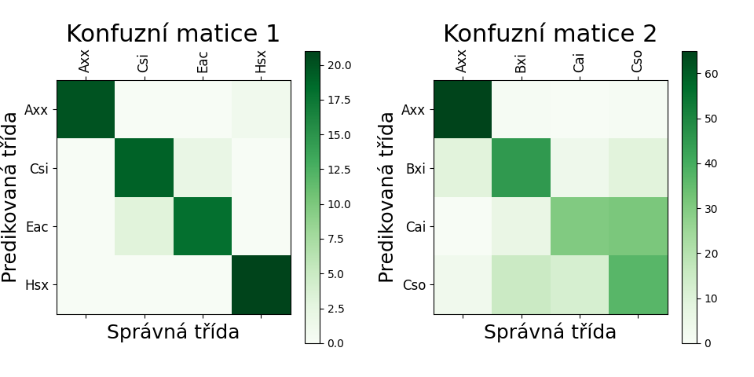It is entirely evident that with these input data the model did not perform as well as in previous cases. The main problem lies in the data themselves, which are very similar to each other. Another obstacle for the training process could have been the configuration of the neural network itself. The best epoch, which had the lowest value of the loss function, came only at epoch 297. The model had difficulty tuning the parameters, since already at epoch 112 the loss function value was below 0.60, but it kept oscillating. For example, at epoch 142 the value was 0.644100. This indicates the model's poor learning capability. Increasing the steps per epoch, or possibly even the learning rate, could help. Looking at confusion matrix 2, see Figure 31, we can observe that group Axx was predicted correctly 65 times and incorrectly only twice, but class Cai was in approximately half the cases confused with class Cso. The class Cso was then evenly misclassified as class Bxi and class Cso.

Obrázek : Konfuzní matice modelů čtyř tříd; vlevo modelu Axx-Csi-Eac-Hsx, vpravo modelu Axx-Bxi-Cai-Cso

## Final Class Model

As we have explored various models with an increasing number of classes, we can now proceed directly to the most important model capable of predicting all classes. The following model includes most classes. Unfortunately, it cannot incorporate classes for which we lack input data, and we also decided to exclude classes with fewer than ten samples. As a result, we had to exclude the classes Fri (0 images), Fro (0), Fhi (0), Fho (1), Eri (2), Ero (3), Fso (3), Eho (5), Fao (8), and Fsc (8). It is evident that the exclusion primarily affected the E and F subclasses, as these occur less frequently on the solar disk compared to other groups. Thus, the final model built from the classes could only differentiate between 50 classes.

This model unfortunately achieved an extremely low accuracy, and it can be stated with certainty that this model is unusable. The main reason for the poor prediction lies in the diametrically different number of samples across individual classes. The class Fko contains only 11 samples, while the Bxo class has over 1,700 images available. The decision to exclude classes with fewer than 10 samples therefore seems mild. The model could potentially function if we were able to collect more input data. If we looked at the prediction accuracies of individual letters, we would find that the first letter was correctly detected in 45% of cases, the second letter in only 36%, and the distribution of spots was managed with an accuracy of 46%. Even though these numbers may seem relatively successful, combining these values yielded an overall accuracy of only 8%. This example clearly illustrates how important it is for each part of the model’s output detection to be accurate.

## Classification by Letters

Given the challenges we encountered due to the lack of data for specific classes during the model creation, an option arose to train a separate neural network model for each subclassification. This approach dramatically reduces the number of classes that the model predicts and significantly increases the number of samples in each class. We thus created datasets by grouping all samples with a specific subclassification into the same class. For instance, when creating a model that predicts the first letter, all samples from classes Hax, Hhx, Hkx, Hrx, and Hsx would be placed into class H.

### Model A-B-C-D-E-F-H

This model should not encounter problems with classification since it has access to a large amount of input data, classifies into a small number of classes, and the differences between the classes are mostly readily visible, as illustrated in Figure 9. The parameters for the convolutional network were set as follows:

Tabulka 9: Vstupní data a parametry CNN modelu A-B-C-D-E-F-H

|  |  |  |  |  |  |  |
| --- | --- | --- | --- | --- | --- | --- |
| Počet tříd | Celkem vzorků | Počet vzorků v třídách  A, B, C, D, E, F, H | Batch size | Steps per epoch | Validation steps | Počet vrstev včetně výstupní |
| 7 | 14 768 | 1668, 2895, 3479, 2872, 1046, 131, 2427 | 32 | 28 | 56 | 9 |

Detailní struktura modelu pak vypadala takto:

Tabulka 10: Struktura CNN modelu A-B-C-D-E-F-H

|  |  |  |  |  |
| --- | --- | --- | --- | --- |
| Vrstva | Typ vrstvy | Počet neuronů | Velikost matice | Aktivační funkce |
| 1 | Konvoluční | 32 | 3×3 | ReLU |
| 2 | Maxpooling |  | 3×3 |  |
| 3 | Konvoluční | 16 | 2×2 | ReLU |
| 4 | Maxpooling |  | 2×2 |  |
| 5 | Konvoluční | 8 | 2×2 | ReLU |
| 6 | Maxpooling |  | 2×2 |  |
| 7 | Flatten |  |  |  |
| 8 | Plně propojená | 32 |  | ReLU |
| 9 | Plně propojená | 5 |  | Softmax |

With this combination of parameters, we obtained the following results:

* Overall accuracy on test data: 61.22%
* Epoch with the lowest loss function value: 246
* Loss function value on validation data: 0.712272

The results indicate that the model achieved relatively decent outcomes. Its accuracy is comparable to that of the Axx-Bxi-Cai-Cso model. By examining Confusion Matrix 1, see Figure 32, we can see that the model's main inaccuracy lies in classifying class F as E. This is due to the limited number of samples available for class F, as well as the fact that classes E and F differ only in size on the disk, which is distorted towards the edges of the disk. The model's accuracy could be improved by adding more layers to the convolutional neural network and increasing the number of neurons in each layer. The issue of similarity between classes D, E, and F, combined with the lack of samples for class F, could be addressed by merging all these samples into one group. After detecting the DEF class, we could analyze the group based on heliographic coordinates and its relative size on the disk: if it is smaller than 10°, it would be class D; between 10° and 15°, class E; and larger than 15 heliographic degrees would indicate class F.

### Model a-h-k-r-s-x

It could be expected that the model for the second subclassification will be less accurate than both letter models since this subclassification refers only to the largest spot, whose relative position within the group is always different, making it difficult to precisely determine where this important spot is located in the image. The parameters for the convolutional network were set as follows:

Tabulka 11: Vstupní data a parametry CNN modelu a-h-k-r-s-x

|  |  |  |  |  |  |  |
| --- | --- | --- | --- | --- | --- | --- |
| Počet tříd | Celkem vzorků | Počet vzorků v třídách  a, h, k, r, s, x | Batch size | Steps per epoch | Validation steps | Počet vrstev včetně výstupní |
| 6 | 14 768 | 3564, 291, 1001, 1280, 3819, 4563 | 48 | 64 | 108 | 7 |

Detailní struktura modelu pak vypadala takto:

Tabulka 12: Struktura CNN modelu a-h-k-r-s-x

|  |  |  |  |  |
| --- | --- | --- | --- | --- |
| Vrstva | Typ vrstvy | Počet neuronů | Velikost matice | Aktivační funkce |
| 1 | Konvoluční | 32 | 3×3 | ReLU |
| 2 | Maxpooling |  | 3×3 |  |
| 3 | Konvoluční | 16 | 2×2 | ReLU |
| 4 | Maxpooling |  | 2×2 |  |
| 5 | Flatten |  |  |  |
| 6 | Plně propojená | 32 |  | ReLU |
| 7 | Plně propojená | 4 |  | Softmax |

With this combination of parameters, we obtained the following results:

* Overall accuracy on test data: 50.00%
* Epoch with the lowest loss function value: 184
* Loss function value on validation data: 0.967319

We see that the model correctly predicted the class only half of the time. By examining Confusion Matrix 2, see Figure 32, we can see that the model struggled with two classes. One of these is class h, which was expected due to the lower number of input data for this class compared to others. The second class causing problems for the model is class r. In this case, the issue is not with the number of input data, but rather the similarity with class x. Furthermore, these two classes logically do not overlap. The label x can only be used if it pertains to group A or B, while the label r is used in the exact opposite case. This logic could be implemented in the final model, significantly increasing accuracy in predicting the middle letter.

### Model c-i-o-x

We can expect the accuracy of this model to be comparable to the accuracy of predicting the first letter, as there are also noticeable differences between the classes. This subclassification pertains to the overall distribution of spots within the group. Therefore, the model should easily estimate which class it is based on information about whether there are spots in the middle, whether they are located at the edges, and so forth. The parameters for the convolutional network were set as follows:

Tabulka 13: Vstupní data a parametry CNN modelu c-i-o-x

|  |  |  |  |  |  |  |
| --- | --- | --- | --- | --- | --- | --- |
| Počet tříd | Celkem vzorků | Počet vzorků v třídách  c, i, o, x | Batch size | Steps per epoch | Validation steps | Počet vrstev včetně výstupní |
| 4 | 14 768 | 1 603, 4 776, 4 288, 4 101 | 56 | 72 | 108 | 7 |

Detailní struktura modelu pak vypadala takto:

Tabulka 14: Struktura CNN modelu c-i-o-x

|  |  |  |  |  |
| --- | --- | --- | --- | --- |
| Vrstva | Typ vrstvy | Počet neuronů | Velikost matice | Aktivační funkce |
| 1 | Konvoluční | 16 | 3×3 | ReLU |
| 2 | Maxpooling |  | 3×3 |  |
| 3 | Konvoluční | 8 | 2×2 | ReLU |
| 4 | Maxpooling |  | 2×2 |  |
| 5 | Flatten |  |  |  |
| 6 | Plně propojená | 32 |  | ReLU |
| 7 | Plně propojená | 4 |  | Softmax |

With this combination of parameters, we obtained the following results:

* Overall accuracy on test data: 68.17%
* Epoch with the lowest loss function value: 130
* Loss function value on validation data: 0.692334

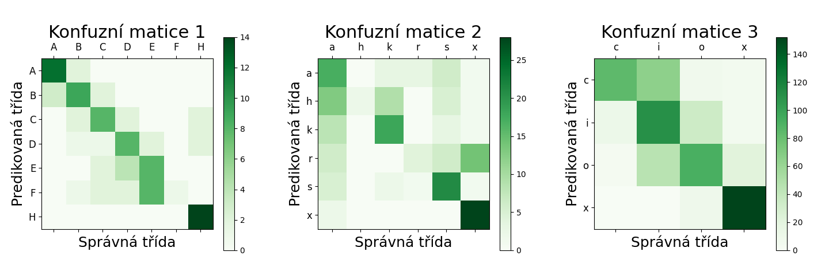The accuracy is comparable to that of the model A-B-C-D-E-F-H. Confusion Matrix 3, see Figure 32, reveals that the model most frequently confused class c with class i, but most of the data remains close to the main diagonal. Achieving higher accuracy could likely be accomplished by modifying the architecture of the neural network, such as by adding more layers or increasing the number of neurons.

Figure 32: Confusion matrix of the letter models; on the left, the model A-B-C-D-E-F-H, in the middle, the model a-h-k-r-s-x, on the right, the model c-i-o-x.

## Final Letter Model

Now that we have available models for all three subclassifications, we can combine them into a single code block. Each model will independently predict its respective subclassification, and the results will then be compiled to form the final group name. Thus, we developed a code structure in which all three models analyzed the same images, and the final group name was constructed from these results.

The outcomes of these three subclassification models were as follows:

* Correct detection of all three letters: 19.02%
* Correct detection of any two letters: 33.74%
* 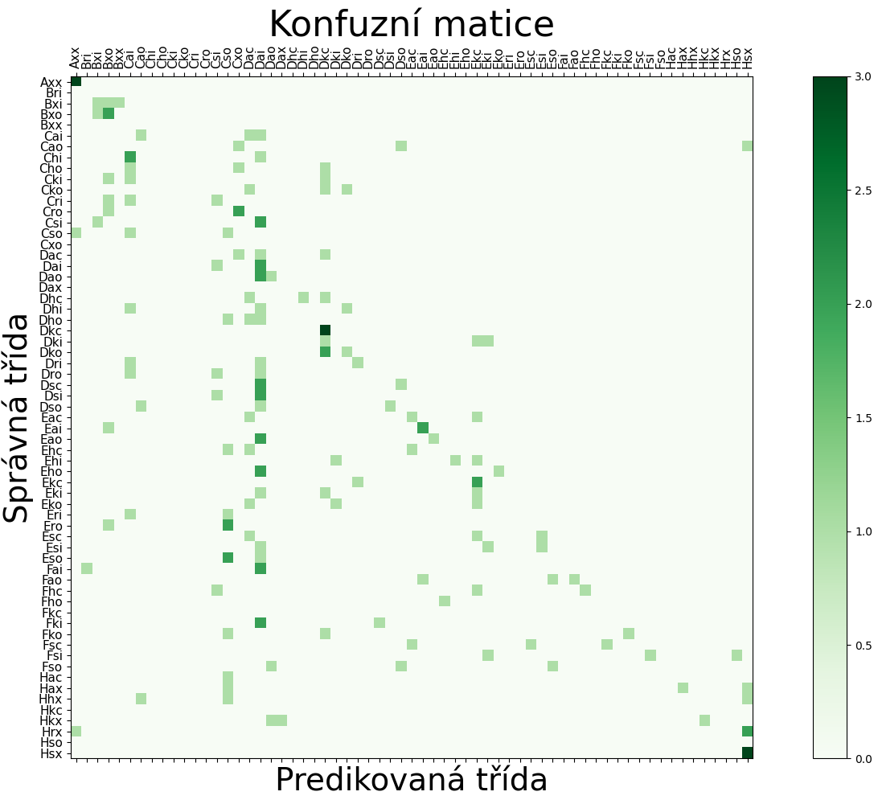Correct detection of only one letter: 32.52%

Figure 33: Confusion matrix of the final letter model.

These results show a significant improvement compared to the final class model, as the accuracy more than doubled. Additionally, we can observe that some data points tend to cluster around the diagonal in the confusion matrix. However, the model currently lacks the implementation of information regarding which classes do not exist; for example, a test image was incorrectly labeled as the group "Bri," as shown in Figure 33.

Implementing this information could lead to much higher accuracy. Since this model is a combination of all the previous letter models, all problematic areas remain, such as the issue with distinguishing between the letters x and r. This issue could potentially be addressed by implementing possible combinations of letters.

Another possible approach to improve the model is to incorporate decision-making based on the size of the classes. For instance, we could distinguish between classes D, E, and F, or between classes s and h based on their relative sizes and spatial distributions in the images.

# Discussion

One of the objectives of this work was to connect two interesting scientific fields: sunspots and machine learning. Therefore, we created a preparatory text discussing both topics, ranging from basic information to important terminology. The text begins with general information about the Sun and introduces the reader to the layers of the Sun and the 11-year solar cycle. It naturally transitions to a more thorough explanation of sunspots, mentioning the history of their observation and the process of their formation. It then focuses more on groups of sunspots, specifically explaining their polarity and addressing their classification. Three classification methods are described in the work: the Zurich classification, the McIntosh classification, and the Mount Wilson classification. For each classification, the differences between its classes are clearly explained, supported by illustrative images of these classes. Subsequently, the work delves into the drawing of the Sun. It provides instructions on how to create such a drawing and explains important information that can be gleaned from an existing drawing protocol, which was necessary for developing a model capable of classifying groups of sunspots.

After the section on sunspots, the work offers a primer on machine learning. It explains concepts such as supervised learning, neural networks, backpropagation, and loss functions. The functioning of individual neurons and entire neural networks is explained, with a particular focus on convolutional neural networks. Additionally, the tools used to create the predictive neural network are mentioned.

The second objective of this work was to create a convolutional neural network model capable of classifying groups of sunspots according to the McIntosh system. This model was successfully created, thus providing proof of concept that machine learning methods can be utilized for this task in solar astronomy. The model design is discussed starting from Chapter 5, where the process necessary for extracting input data in the form of annotated groups of sunspots from publicly available drawings can be tracked step by step. This section is written to clearly describe all necessary steps so that they can be repeated, enabling anyone to create a similar model.

Generally, it is important to correctly identify the goals of the neural network model during training, and it is often beneficial to consider whether the problem can be solved more simply without using machine learning. Additionally, it is advisable to set an expected accuracy for the model. The preparation of input data should not be underestimated. Input data can take virtually any form, including images, numerical files, videos, audio, texts, large databases, documents, and many others. This data should primarily contain relevant information and a negligible amount of errors. For example, instead of using colored input images, it might be advantageous to consider using grayscale images. By making this change, the model will work with only one channel instead of three, making it faster. In this work, we ultimately chose to train only on grayscale input data because the color information was not significantly different. Once the data is prepared, training can begin. It is necessary to select a training style and environment. We chose supervised learning. The structure, parameters, and number of neurons in the neural networks were selected individually for each task, and we examined the functioning of the models under various settings. For the activation of hidden layers, we used the ReLU function, while the softmax function was employed at the network output. After training the model, it is generally advisable to think about effectively determining its accuracy. Once the model is sufficiently accurate, it is ready for deployment.

Following the chapter describing the preparation for model training, there are eight models that achieve predictions at a certain level. Where necessary, the parameters of the models and descriptions explaining the model behavior in words are provided. Each of these neural networks lists the accuracy achieved on test data, the epoch in which this accuracy was reached, and the loss function value on validation data in that epoch. For selected models, where appropriate, a confusion matrix is included to better illustrate the model's accuracy. To achieve greater accuracy, we transitioned to training models that do not input individual classes of the McIntosh system but focus on only one subclassification.

## Complications in Input Data Preparation

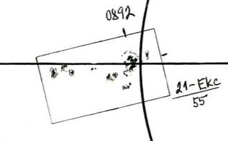The adjustment of input data was not very effective and could definitely be improved, but since this work was intended to serve as proof of concept, it was sufficient for us to extract only 15,494 samples of sunspot groups, which were later used as input data. This accounts for only about 25% of all groups recorded electronically. The main reason for losing so many groups was that a group located in the drawing protocol near the inner circle or auxiliary axis is often bisected by this line (see Figure 34), causing the program to not detect such a group as a single rectangle but rather as multiple shapes. This problem was left open for resolution since proving the model's functionality does not require as much data as thorough training would.

Figure 34: Group Ekc intersected by both a circle and an axis.

Another obstacle that needed to be overcome during data preparation was the orientation of the drawings. Until August 16, 2012, drawings were made with the north at the bottom, but after this date, they were rotated 180°, placing north at the top. This rotation caused different calculations of the coordinates of the groups, as the angle with respect to the north is necessary for their computation. We accounted for this different north position in the code that calculated heliocentric coordinates.

A debatable step in the preparation of input data was correcting the width of the drawings to 2000 px. This adjustment inevitably leads to the loss of information that could potentially be useful. However, since the width change concerned only a small number of images, it was not necessary to address this problem further. If we had, for example, drawings from multiple observatories that were likely scanned differently, we would have to consider this issue more seriously.

## Extension of the Work

Since the work successfully trained a functioning model, it is possible to create different functioning or more accurate models or to devise further possibilities for utilizing machine learning in astronomy in general.

### Creation of Additional Models

There are numerous opportunities to build upon the models created in this work. The models include texts evaluating the quality and accuracy of the models. These texts also describe possible steps that can be taken to improve accuracy. Furthermore, it would be possible to enhance the detection of sunspots in the drawings, thereby obtaining approximately four times more input data than we worked with in this study. Another possibility, which we also attempted, would be to obtain drawings from other observatories, likely foreign ones. We asked the Kanzelhöhe Observatory if they would also provide us with their drawings. The staff at the observatory kindly sent us their data (see Figure 8), which included tens of thousands of different drawings and photographs. Unfortunately, at this observatory, groups are not bounded by rectangles, making detection more challenging, although not impossible. Additionally, this observatory employs the Zurich classification, and we did not receive any electronic data containing digitized group labels.

Models could also be trained on the same input data but with more neurons in more layers. These models would likely achieve greater accuracy, as they would have a greater potential to learn. However, such training would be much more demanding and would require appropriate technical specifications for the computer. The training of letter models was conducted on a Dell Latitude E6420 notebook, taking about five hours.

An interesting task would be to incorporate information such as the relative position of the group on the disk and its heliographic coordinates into the input data. The model could then better understand the flattening of some groups at the edge of the solar disk. Another potential extension could be to create a program that would work with data labeled with a non-existent class and attempt to correct this information.

Another approach to training models is to convert all group names of sunspots into values of their CV index and predict only the number indicating the group. This way, it could prevent completely incorrect group detection, as the model would predict a number on a scale from 1 to 60, and similar groups would have similar numbers.

Data could also be used to train a completely different type of model that could predict the evolution of groups over time, as we have data from which we can select specific groups and track their development over time.

### Implementation by Observatories

Once the methods for finding groups in the drawings are fully functional and flexible, and once the model's predictions are sufficient, it will be possible to create a program that takes a clean drawing with only the marked sunspots, correctly finds the groups, and determines their classification. In connection with a visit to the Astronomical Institute's observatory in Ondřejov, we created a similar program. This program, upon execution, took a drawing in the same folder, identified the sunspots using rectangles, predicted their classification, and wrote the final class on the image. This was merely a prototype, but the final program could function similarly. This program could then serve to verify manually classified sunspots.

# Conclusion

We successfully created a functioning convolutional neural network model capable of classifying groups of sunspots according to the McIntosh system. This model is described in Chapter 6.5. The work can be understood as proof of concept that machine learning can be applied in a field such as solar astronomy.

The work also includes a detailed section that clearly and understandably introduces the problem from the perspective of both branches of science: solar astronomy and machine learning. Additionally, the work describes the process necessary to create the final model and explores several other possible directions for future development in this field.

# Použitá literatura

[1] Astronomická jednotka. In: *Wikipedia: the free encyclopedia* [online]. San Francisco (CA): Wikimedia Foundation, c2024 [cit. 2024-03-11]. Dostupné z: https://cs.wikipedia.org/w/index.php?title=Astronomick%C3%A1_jednotka&oldid=23683910

[2] Solar radius. In: *Wikipedia: the free encyclopedia* [online]. San Francisco (CA): Wikimedia Foundation, c2024 [cit. 2024-03-11]. Dostupné z: https://en.wikipedia.org/w/index.php?title=Solar_radius&oldid=1210839025

[3] Struktura Slunce. *POZOROVÁNÍ SLUNCE* [online]. [cit. 2024-03-12]. Dostupné z: https://pozorovanislunce.eu/slunce/struktura-slunce.html

[4] The Sun. In: *Wikipedia: the free encyclopedia* [online]. San Francisco (CA): Wikimedia Foundation, c2024 [cit. 2024-03-12]. Dostupné z: https://upload.wikimedia.org/wikipedia/commons/thumb/d/d4/Sun_poster.svg/1024px-Sun_poster.svg.png

[5] Slunce. *ALDEBARAN* [online]. [cit. 2024-03-14]. Dostupné z: https://www.aldebaran.cz/astrofyzika/sunsystem/slunce.php

[6] What are some historical observations of the Sun? *NSF NCAR* [online]. [cit. 2024-03-14]. Dostupné z: https://www2.hao.ucar.edu/education/about-the-sun/what-are-some-historical-observations-sun

[7] The Historical Sunspot Record. In: *Ice Core Records – From Volcanoes to Supernovas* [online]. [cit. 2024-03-14]. Dostupné z: https://chandra.harvard.edu/edu/formal/icecore/The_Historical_Sunspot_Record.pdf

[8] Mehrere Sonnenfleckengruppen mit Umbra und Penumbra. In: *Wikipedia: the free encyclopedia* [online]. San Francisco (CA): Wikimedia Foundation [cit. 2024-03-14]. Dostupné z: https://de.wikipedia.org/wiki/Sonnenfleck#/media/Datei:Sunspots.JPG

[9] Hvězdy – Sluneční skvrny. Astronomia [online]. c2024 [cit. 2024-03-14]. Dostupné z: https://astronomia.zcu.cz/hvezdy/slunce/744-slunecni-skvrny

[10] Sunspot butterfly diagram. In: *Wikipedia: the free encyclopedia* [online]. San Francisco (CA): Wikimedia Foundation [cit. 2024-03-14]. Dostupné z: https://upload.wikimedia.org/wikipedia/commons/thumb/c/c4/Sunspot_butterfly_diagram.svg/800px-Sunspot_butterfly_diagram.svg.png

[11] Sluneční skvrna. In: *Wikipedia: the free encyclopedia* [online]. San Francisco (CA): Wikimedia Foundation [cit. 2024-03-14]. Dostupné z: https://cs.wikipedia.org/wiki/Slune%C4%8Dn%C3%AD_skvrna

[12] Sluneční cyklus. In: *Wikipedia: the free encyclopedia* [online]. San Francisco (CA): Wikimedia Foundation [cit. 2024-03-14]. Dostupné z: https://cs.wikipedia.org/wiki/Slune%C4%8Dn%C3%AD_cyklus

[13] Sun magnetic field after omega effect. In: *Wikipedia: the free encyclopedia* [online]. San Francisco (CA): Wikimedia Foundation [cit. 2024-03-14]. Dostupné z: https://upload.wikimedia.org/wikipedia/commons/thumb/3/33/Sun%27s_magnetic_field_after_omega_effect.svg/768px-Sun%27s_magnetic_field_after_omega_effect.svg.png

[14] Faculae and Sunspots at Solar Maximum. In: *Wikipedia: the free encyclopedia* [online]. San Francisco (CA): Wikimedia Foundation [cit. 2024-03-14]. Dostupné z: https://en.wikipedia.org/wiki/Solar_facula#/media/File:Faculae_and_Sunspots_at_Solar_Maximum.tif

[15] Sluneční skvrna. *POZOROVÁNÍ SLUNCE* [online]. [cit. 2024-03-14]. Dostupné z: https://pozorovanislunce.eu/vykladovy-slovnicek/slunecni-skvrna.html

[16] Graf slunečních cyklů. *Astronomický ústav AV ČR* [online]. [cit. 2024-03-14]. Dostupné z: https://www.asu.cas.cz/~sunwatch/public/files/Slunce/Grafy/graf_2009_2018/2018_SC_17-24.jpg

[17] Minislovníček: Relativní číslo. *HVĚZDÁRNA V ROKYCANECH A PLZNI* [online]. [cit. 2024-03-14]. Dostupné z: https://www.hvr.cz/2011/09/26/minislovnicek-relativni-cislo/

[18] Relativní číslo slunečních skvrn. *POZOROVÁNÍ SLUNCE* [online]. [cit. 2024-03-14]. Dostupné z: https://pozorovanislunce.eu/vykladovy-slovnicek/relativni-cislo-slunecnich-skvrn.html

[19] CARRASCO, V.M.S., L. LEFÈVRE, J.M. VAQUERO a M.C. GALLEGO. *Equivalence relations between the Cortie and Zürich sunspot group morphological classifications* [online]. 17 [cit. 2024-03-14]. Dostupné z: https://arxiv.org/ftp/arxiv/papers/1503/1503.08724.pdf

[20] Examples of the Zuerich classification. In: *Astronomický ústav AV ČR* [online]. [cit. 2024-03-14]. Dostupné z: https://www.asu.cas.cz/~sunwatch/public/files/other/clanky/2021/Examples-of-the-Zuerich-classification-of-sunspot-groups-source-Bray-and-Loughhead.jpg

[21] Beckovo číslo slunečních skvrn. *POZOROVÁNÍ SLUNCE* [online]. [cit. 2024-03-14]. Dostupné z: https://www.pozorovanislunce.eu/vykladovy-slovnicek/beckovo-cislo-slunecnich-skvrn.html

[22] *Observatorium Kanzelhöhe* [online]. [cit. 2024-03-19]. Dostupné z: https://www.kso.ac.at/index_en.php

[23] McIntoshova klasifikace. In: *Astronomický ústav AV ČR* [online]. [cit. 2024-03-14]. Dostupné z: https://www.asu.cas.cz/~sunwatch/public/files/other/clanky/zonnevlekclassificatie-1.jpg

[24] HILL, Rik, JENKINS, Jamey, ed. *Guidelines for the Observation of White Light Solar Phenomena* [online]. 3rd ed. 2010 [cit. 2024-03-14]. Dostupné z: https://www.alpo-astronomy.org/solarblog/wp-content/uploads/wl_2010.pdf

[25] PROJEKCE - ZÁKRES SLUNEČNÍ FOTOSFÉRY. *Astronomický ústav AV ČR* [online]. [cit. 2024-03-14]. Dostupné z: https://www.asu.cas.cz/~sunwatch/cs/stranka/kresba

[26] Tabulka CV index. In: *Astronomický ústav AV ČR* [online]. [cit. 2024-03-14]. Dostupné z: https://www.asu.cas.cz/~sunwatch/public/files/other/clanky/2021/tab.png

[27] Graf CV index. In: *Astronomický ústav AV ČR* [online]. [cit. 2024-03-14]. Dostupné z: https://www.asu.cas.cz/~sunwatch/public/files/other/clanky/2021/CV.png

[28] Kresba z 11. 04. 2022. In: *Astronomický ústav AV ČR* [online]. [cit. 2024-03-14]. Dostupné z: https://www.asu.cas.cz/~sunwatch/new/www/public/files/archive_patrol/sunspot_drawings/2022/220411dr.jpg

[29] Projekce. In: *Astronomický ústav AV ČR* [online]. [cit. 2024-03-14]. Dostupné z: https://www.asu.cas.cz/~sunwatch/new/www/public/files/other/projekce.jpg

[30] Česlopol sbírá kresby Slunce. *Astronomický ústav AV ČR* [online]. [cit. 2024-03-14]. Dostupné z: https://www.asu.cas.cz/~sunwatch/new/www/cs/clanek/kresby

[31] Carringtonova rotace. *POZOROVÁNÍ SLUNCE* [online]. [cit. 2024-03-14]. Dostupné z: https://www.pozorovanislunce.eu/vykladovy-slovnicek/carringtonova-rotace.html

[32] Zjištění údajů z kresby. In: *Astronomický ústav AV ČR* [online]. [cit. 2024-03-14]. Dostupné z: https://www.asu.cas.cz/~sunwatch/new/www/public/files/other/img40.png

[33] *ChatGPT* [online]. [cit. 2024-03-15]. Dostupné z: https://chat.openai.com/

[34] *DALL·E 2* [online]. © 2015 – 2024 [cit. 2024-03-15]. Dostupné z: https://openai.com/dall-e-2

[35] Strojové učení. In: *Wikipedia: the free encyclopedia* [online]. San Francisco (CA): Wikimedia Foundation [cit. 2024-03-15]. Dostupné z: https://cs.wikipedia.org/wiki/Strojov%C3%A9_u%C4%8Den%C3%AD

[36] *Gemini* [online]. [cit. 2024-03-15]. Dostupné z: https://gemini.google.com/

[37] Colored neural network. In: *Wikipedia: the free encyclopedia* [online]. San Francisco (CA): Wikimedia Foundation [cit. 2024-03-15]. Dostupné z: https://en.wikipedia.org/wiki/Neural_network_(machine_learning)#/media/File:Colored_neural_network.svg

[38] Activation function. In: *Wikipedia: the free encyclopedia* [online]. San Francisco (CA): Wikimedia Foundation [cit. 2024-03-15]. Dostupné z: https://en.wikipedia.org/wiki/Activation_function

[39] What is backpropagation really doing? In: *YouTube* [online]. [cit. 2024-03-15]. Dostupné z: https://www.youtube.com/watch?v=Ilg3gGewQ5U

[40] JEŘÁBEK, Vladimír. *HLUBOKÉ NEURONOVÉ SÍTĚ PRO ROZPOZNÁNÍ TVÁŘÍ VE VIDEU* [online]. Brno, 2018 [cit. 2024-03-15]. Dostupné z: https://www.vut.cz/www_base/zav_prace_soubor_verejne.php?file_id=181536. Bakalářská práce. Vysoké učení technické v Brně.

[41] *Underfitting, Overfitting* [online]. In: *SPRINGER NATURE*. [cit. 2024-03-15]. Dostupné z: https://media.springernature.com/full/springer-static/image/art%3A10.1007%2Fs13244-018-0639-9/MediaObjects/13244_2018_639_Fig9_HTML.png?as=webp

[42] Training, validation, and test data sets. In: *Wikipedia: the free encyclopedia* [online]. San Francisco (CA): Wikimedia Foundation [cit. 2024-03-15]. Dostupné z: https://en.wikipedia.org/wiki/Training,_validation,_and_test_data_sets

[43] LECUN, Yann, Léon BOTTOU, Yoshua BENGIO a Patrick HAFFNER. *GradientBased Learning Applied to Document Recognition* [online]. 1998, 46 [cit. 2024-03-17]. Dostupné z: http://vision.stanford.edu/cs598_spring07/papers/Lecun98.pdf

[44] *Input, Kernel, Output* [online]. In: *imgbb*. [cit. 2024-03-15]. Dostupné z: https://i.ibb.co/Lz5Zc0h/nagesh-cnn-intro-7.png

[45] DUBINA, Tomáš. *Využití neuronových sítí v BCI systémech založených na evokovaných potenciálech SSVEP* [online]. Plzeň, 2020 [cit. 2024-03-15]. Dostupné z: https://dspace5.zcu.cz/bitstream/11025/41804/1/Bakalarska_prace.pdf. Bakalářská práce. Západočeská univerzita v Plzni, Fakulta aplikovaných věd.

[46] ZACHA, Jiří. *Konvoluční neuronové sítě pro klasifikaci objektů z LiDARových dat* [online]. Praha, 2019 [cit. 2024-03-15]. Dostupné z: https://dspace.cvut.cz/bitstream/handle/10467/82351/F3-BP-2019-Zacha-Jiri-Konvolucni_neuronove_site_pro_klasifikaci_objektu_z_LiDARovych_dat.pdf. Bakalářská práce. České vysoké učení technické v Praze.

[47] Max pooling. In: *Wikipedia: the free encyclopedia* [online]. San Francisco (CA): Wikimedia Foundation [cit. 2024-03-15]. Dostupné z: https://upload.wikimedia.org/wikipedia/commons/e/e9/Max_pooling.png

[48] KOLÁŘ, Tomáš. *Odhad pozice v těle pacienta ve snímcích získaných pomocí trojrozměrných zobrazovacích metod* [online]. Plzeň, 2017 [cit. 2024-03-15]. Dostupné z: https://dspace5.zcu.cz/bitstream/11025/27100/1/d1.pdf. Diplomová práce. Západočeská univerzita v Plzni, Fakulta aplikovaných věd.

[49] Yamashita, R., Nishio, M., Do, R.K.G. *et al.* Convolutional neural networks: an overview and application in radiology. *Insights Imaging* **9**, 611–629 (2018). https://doi.org/10.1007/s13244-018-0639-9

[50] *Python* [online]. c2001-2024 [cit. 2024-03-15]. Dostupné z: https://www.python.org/

[51] *TensorFlow* [online]. [cit. 2024-03-15]. Dostupné z: https://www.tensorflow.org/

[52] *Keras* [online]. [cit. 2024-03-15]. Dostupné z: https://keras.io/

[53] *Visual Studio Code* [online]. c2024 [cit. 2024-03-15]. Dostupné z: https://code.visualstudio.com/

[54] *GitHub* [online]. c2024 [cit. 2024-03-15]. Dostupné z: https://github.com/

[55] *Git* [online]. [cit. 2024-03-15]. Dostupné z: https://git-scm.com/

[56] Ondřejovská hvězdárna. *Astronomický ústav AV ČR* [online]. c2024 [cit. 2024-03-19]. Dostupné z: https://www.asu.cas.cz/cz/verejnost-a-media/prohlidky-pro-verejnost

[57] LunarEagle. *GitHub* [online]. c2024 [cit. 2024-03-18]. Dostupné z: https://github.com/Plice13/LunarEagle

[58] Optické rozpoznávání znaků. In: *Wikipedia: the free encyclopedia* [online]. San Francisco (CA): Wikimedia Foundation [cit. 2024-03-15]. Dostupné z: https://cs.wikipedia.org/wiki/Optick%C3%A9_rozpozn%C3%A1v%C3%A1n%C3%AD_znak%C5%AF

[59] How to build a machine learning model in 7 steps. *TechTarget* [online]. c2024 [cit. 2024-03-20]. Dostupné z: https://www.techtarget.com/searchenterpriseai/feature/How-to-build-a-machine-learning-model-in-7-steps

[60] *Dell Latitude E6420 and E6420 ATG Owner's Manual* [online]. 145 [cit. 2024-03-19]. Dostupné z: https://dl.dell.com/manuals/all-products/esuprt_laptop/esuprt_latitude_laptop/latitude-e6420_owner's%20manual_en-us.pdf

# Seznam obrázků a tabulek

Tabulka 1: Vstupní data a parametry CNN modelu Axx-Dai 30

Tabulka 2: Struktura CNN modelu Axx-Dai 30

Tabulka 3: Vstupní data a parametry CNN modelu Axx-Bxo 31

Tabulka 4: Struktura CNN modelu Axx-Bxo 31

Tabulka 5: Vstupní data a parametry CNN modelu Axx-Csi-Eac-Hsx 32

Tabulka 6: Struktura CNN modelu Axx-Csi-Eac-Hsx 33

Tabulka 7: Vstupní data a parametry CNN modelu Axx-Bxi-Cai-Cso 34

Tabulka 8: Struktura CNN modelu Axx-Bxi-Cai-Cso 34

Tabulka 9: Vstupní data a parametry CNN modelu A-B-C-D-E-F-H 35

Tabulka 10: Struktura CNN modelu A-B-C-D-E-F-H 36

Tabulka 11: Vstupní data a parametry CNN modelu a-h-k-r-s-x 36

Tabulka 12: Struktura CNN modelu a-h-k-r-s-x 37

Tabulka 13: Vstupní data a parametry CNN modelu c-i-o-x 37

Tabulka 14: Struktura CNN modelu c-i-o-x 38

1. The astronomical unit is closely related to the distance between the Sun and the Earth; it is a unit of distance used in astronomy. Its value is defined as 1 AU = 149,597,870,700 meters [1], and this distance approximately corresponds to the distance from the Earth to the Sun.
2. The precise value of the solar radius is 695,700,000 meters [2].
3. In the case of the first layer, the data is taken directly from a portion of the input image.